
Game Design Doc
Chapter 8
User Interface

Version 2.01
18/01/2006
Maintainer: Terry Greer

8 User Interface 3
8.1 User Interface – Design Objectives 3
8.1.1. User Interface Presentation 3
8.1.1.1. The Loading Screen 3
8.2 Single-Player Game GUI 4
8.2.1. Main Menu – General 4
8.2.2. New Game 6
8.2.3. Continue Game UI 6
8.2.4. Load Game 7
8.2.5. Options Menu 8
8.2.6. Bonus Menu 9
8.3 Multiplayer Game GUI – Detailed Analysis 9
8.3.1. Multiplayer Menu – General 9
8.3.2. Live Service UI 11
8.3.3. System Link UI 11
8.3.4. Avatar Selection 12
8.3.5. Weapons Workshop 13
8.3.6. Friends Menu 14
8.3.7. Host Game Menu 14
8.4 Pause Menus 15
8.4.1. Pause Game Menu 15
8.4.2. Pause Cutscene Menu 16
8.4.3. Pausing In Multiplayer 16
8.5 Map Screen 16
8.6 Saving Games 17
8.6.1. User Profiles 17
8.6.2. Game Saves 17
8.6.3. Game Saves Design Goals: 17
8.6.4. Saving a Game 17
8.6.5. Save Slot Info 18
8.6.6. Save Game Prompts 18
8.6.7. Save Game Info 18

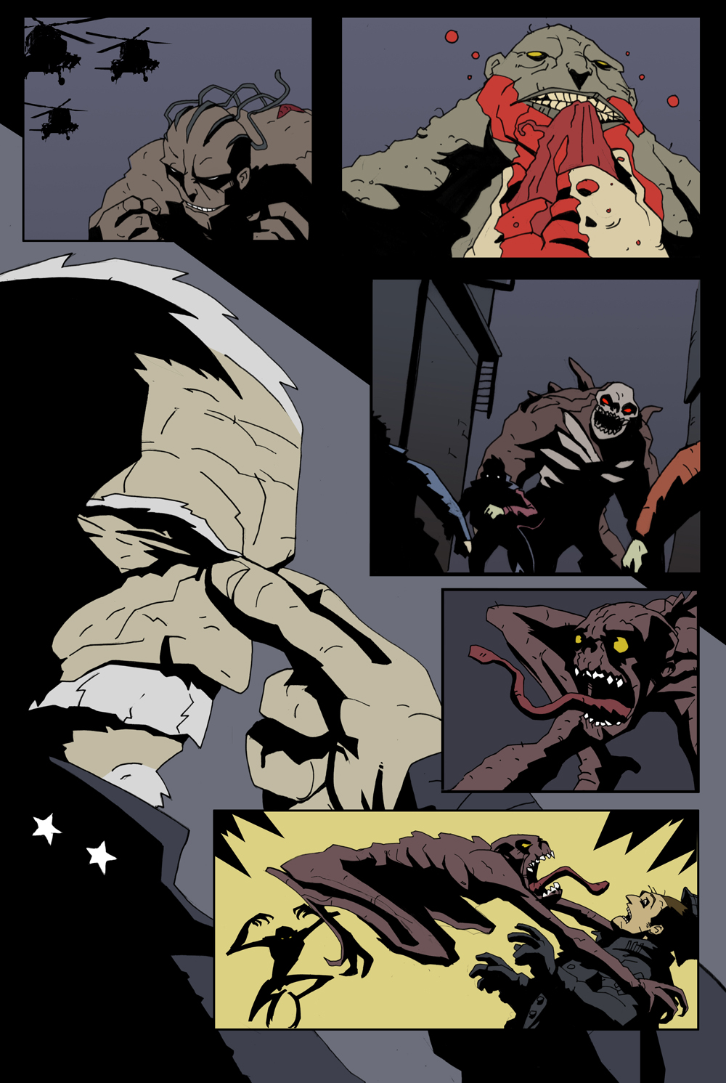

User Interface
The purpose of this document is to detail the menu layouts and requirements with respect to all front-end and in-game user interfaces (UI) for Possession. The aim is to provide a clear step-by-step storyboard for each UI related menu page that the user will encounter as they progress through either the single player or multiplayer game.

In some circumstances pages will be duplicated as they appear in different game modes and this is deliberate as the document also intends to show how the UI menu pages relate to each other in different circumstances. Where possible, correct TRC related text strings have been indicated based upon current TRC documentation though many of these text strings will be subject to change throughout the development period.

User Interface – Design Objectives
- To ensure that the front-end user interface for Possession is easily navigable by the user.
- To design a user interface that quickly allows a player to proceed into the game with a minimum of time and fuss.
- To ensure that the user interface is visually appealing and interesting.
- To ensure that the user interface is designed so as to be cross-platform yet agrees with all platform specific TRC regulations.
- To design a multiplayer user interface that is both cross-platform yet suitable for specific platform online requirements.

User Interface Presentation

Proper presentation of the user interface is key in representing game quality and maintaining player interest through the front-end user interfaces. A good user interface is a user’s first indicator of the quality of a product, and by bearing this in mind through the development of the user interface a good first impression is easy to cultivate.

Consistency of style is important to creating a professional UI. The following elements should remain consistent throughout all menu screens:-

- Background Images: Whether static or mobile (movie clips or in-game footage) these should maintain the atmosphere of the game, through similar colour tones and contrast levels.
- Font: Keeping to a small number of fonts (usually one for options and titles and another for help messages, subtitles and descriptions) helps maintain consistency.
- Progression/Regression Mechanic: The user should always know in which direction they are moving through the menus. The Back or Cancel Button must always regress them to the previous menu, not take them somewhere unexpected.
- Clarity: Menus should be crisp and clear, whatever atmospheric style is being used. If menus feature dark backgrounds, text should be in bright colours. If brighter backgrounds are to be used (e.g. in-game footage from a sunlit level), either darker text, or text with dark drop shadows should be used.

The Loading Screen

The loading screen that takes the player from a menu selection (New Game, Load Game or Continue Game) into the game should be presented as dynamically as possible.

This means a smooth transition from menu to loading screen, and another from the loading screen to the game itself, by way of a smooth fade or wipe.

The loading screen should contain elements to keep the player’s attention and interest – if the player looks away during a game load, their attention could be lost and the loading screen has failed its purpose. Such elements include:-

- Animated images: A backdrop may animate, possibly in such a way as to actually be a disguised progress bar, e.g. blood dripping down the screen or some kind of glare effect passing through the game logo.
- Hint text: Text can be used during the load to offer hints to the user. These hints should relate to the save file being loaded; if a New Game is starting, these might offer basic control tips to move the main character, as that is the first thing a player may want to try. If the user is loading a game that was saved shortly after unlocking a new zombie type, the text might give an explanation of that zombie, or a hint of an interesting way to use the zombie’s abilities that the player might not have thought of themselves.

The game should not have an actual progress bar, since these tend to draw the user’s attention to the fact that they are waiting for the game to load.

Possession will only display a loading screen when starting a new game or continuing from a saved file. All other loading is conducted in the background while the user is still playing.

Single-Player Game GUI

Main Menu – General

When Possession boots up for the first time, it will progress through a number of automated licensing and logo screens. The first interactive menu will have one selectable option – ‘Press Start’. The user presses the START button on their controller to proceed.

Note 1:. If the system detects no memory storage device attached to the console system, a warning will appear that alerts the player that they will not be able to record their progress. The player can continue to the create new user profile screen and then the main menu, but unless a storage device is attached any settings that the player changes will be lost when they leave the game.

Note 2: If the system detects no saved profiles on the console system, then a warning will be presented to the player and they will need to create a profile before the game can proceed to the next stage

Note 3: On certain systems it may be a requirement for the game or console to check the user’s online status, signing the player into their online account automatically during boot-up. If so, then a message showing their online status will be displayed to the user when entering the main menu.

The main menu shows the core selectable game modes and options that are available to a new or returning player. The user highlights the selectable options using either the Left Analogue Stick or Directional Pad and presses the selection button (X for PS3 or A for 360) to select any highlighted option. Selecting an option will either take the user into a further sub-menu associated with the mode/option or will take the player directly into the single-player game at the requested start position.

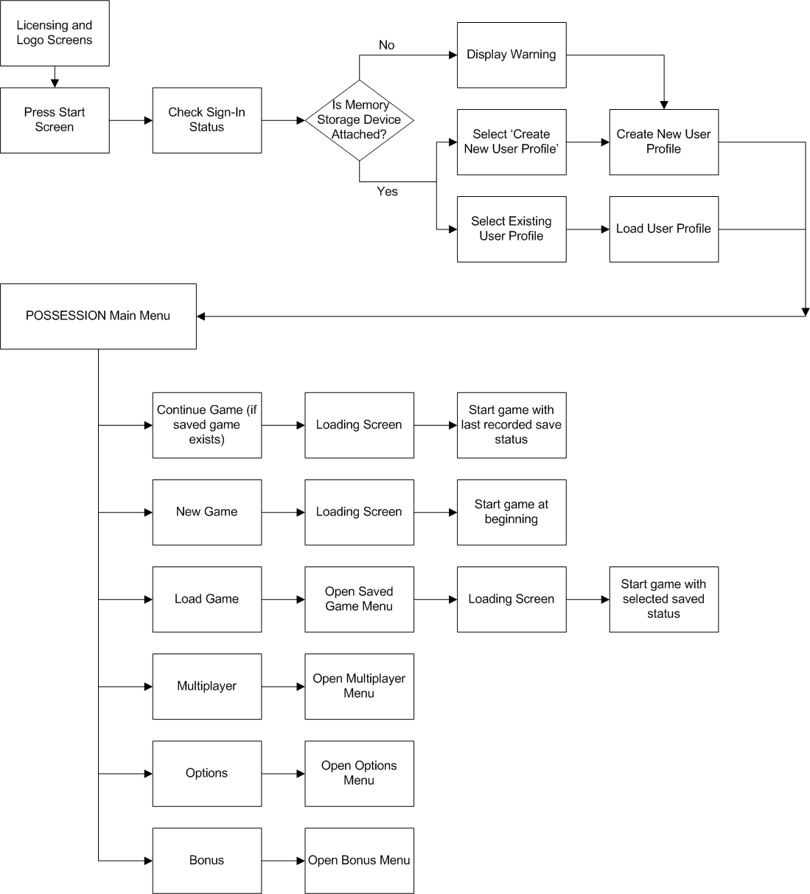

The selectable options are as follows:

- Continue: This option will only appear if the user has already started a single-player game and saved their progress to a memory storage device. If this option is selected, the user will be automatically taken to their last recorded game save position.
- New Game: An option to begin a new game will always be available for selection within the main menu. When booting Possession for the very first time, or if there is no save game data available, then the user will only have the option of selecting a new game.
- Load Game: If Possession game save data already exists then the player may select a previous saved game as their requested start/continue position. When selecting to load a game, the user will be taken to the Possession saved game menu. This menu will contain a complete list of Possession saved games for the attached memory storage device and selected user profile.
- Multiplayer: For all online multiplayer game options – starting or joining a multiplayer game or tinkering with multiplayer options – the user must select this option. Doing so will take the player into the Multiplayer menu.
- Options: Selecting this option will take the user to the Options menu. This menu allows them to adjust options such as display, sound and vibration.
- Bonus: Once some bonus content has been unlocked, this option will take the user to the Bonus menu, from which they can view the unlocked content.
Note: The user may take a step backwards from any menu to the previous one at any stage by pressing either the ∆ or Y button.

New Game

To begin an entirely new game the user must select ‘New Game’ from the Main Menu. This immediately triggers the game’s introduction sequence, after which the player will be taken to the very start of the Possession single-player game.

If the user attempts to play Possession without any memory storage unit attached to the console, then they will only be able to select a new game or multiplayer game to play. In addition, the user will lose any profile that they creates for the purposes of playing either a single player or multiplayer game when they power down their system or quit the game.
Note: Once the player fully completes the single-player game, further new game options become enabled. These relate to replaying the game in special modes, such as Super Enslaver Mode, in which a Stage IV Enslaver is unlocked right from the start.

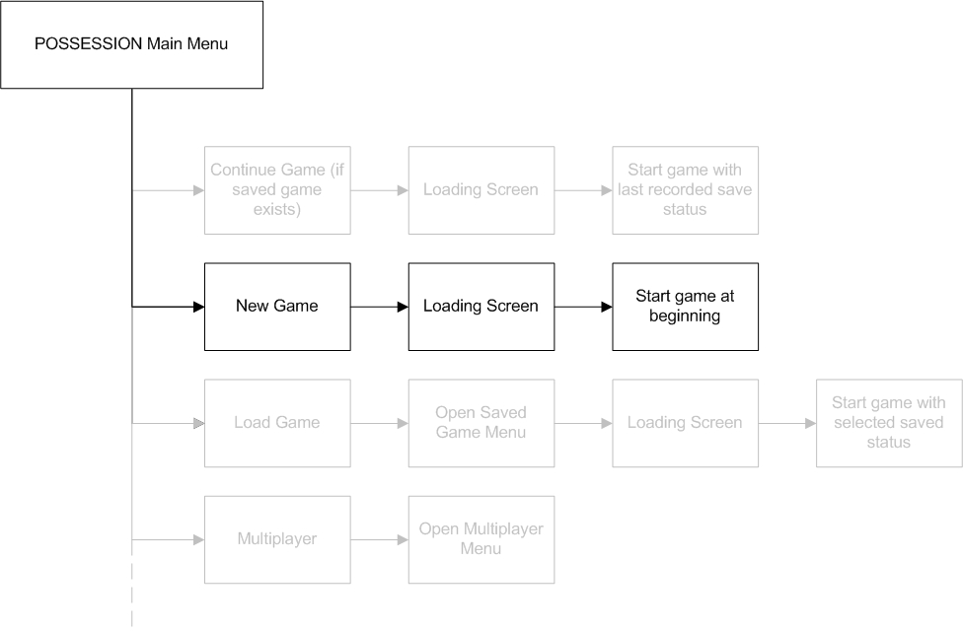

Continue Game UI

When booting up Possession, the user will be given the option of continuing their game from the last saved game position. Selecting this option will load the last recorded game save for the profile that they have selected. This is a shortcut load that prevents the player from having to navigate their save files for the last one they were playing.

If the player wishes to load an older save game, they will instead need to choose the desired save game position from the Load Game menu.

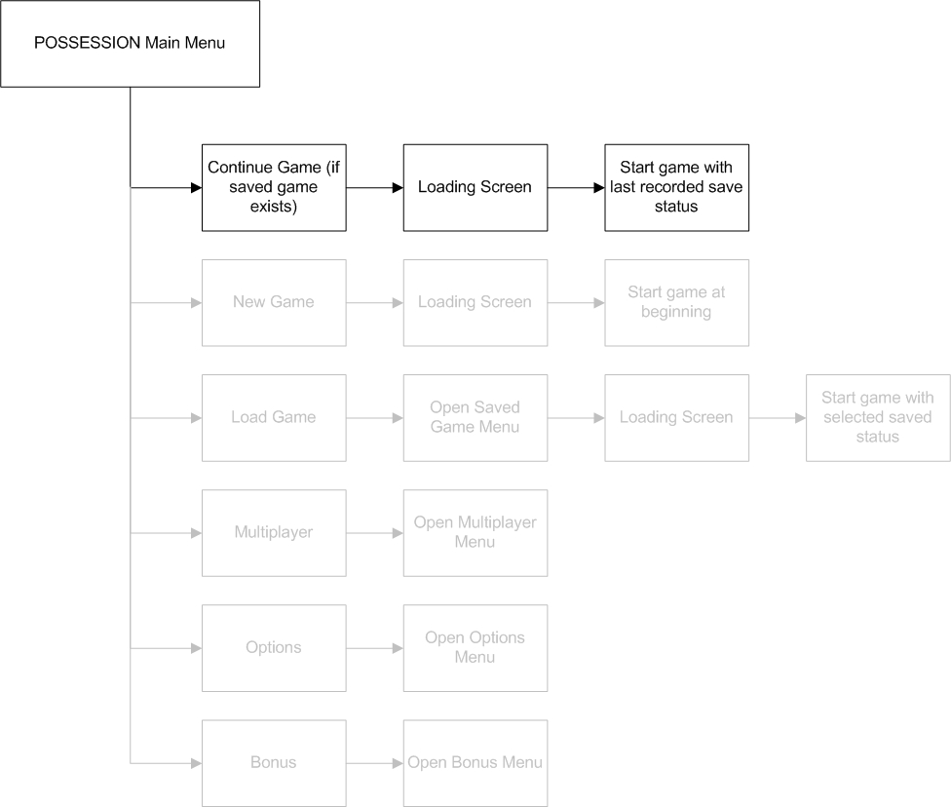

Load Game

Each time Possession boots up it will search for any existing saved games from the attached memory storage devices and the user profile selected. The player will be able to access this list of saved games from within the Load Game menu, selectable from the main menu. Saved games will be listed in order of date and time, with the most recent save shown at the top of the list. Each saved game will contain the following information:-

- An in-game image showing the game position view/frame at the time of saving.
- The date and time of the save.
- The user profile associated with the save.
- An indication of current game-world position.
- Amount of time played within the specified single-player game at the time of the save.

Once the user has selected a saved game to load, they will receive a message asking them to confirm their decision. Once confirmed the game will load the requested saved game and the player will enter play from the position specified.

The user may also choose to load a saved game from within the Pause menu, whilst already playing a single-player game. This takes the player to the Saved Game Menu, from which they can select a saved game to start from. The player will then be warned that they will lose any unsaved data in their current game, and asked to confirm the decision and continue with the load. For more information on saved games and pause/options menu, see the appropriate sections below.

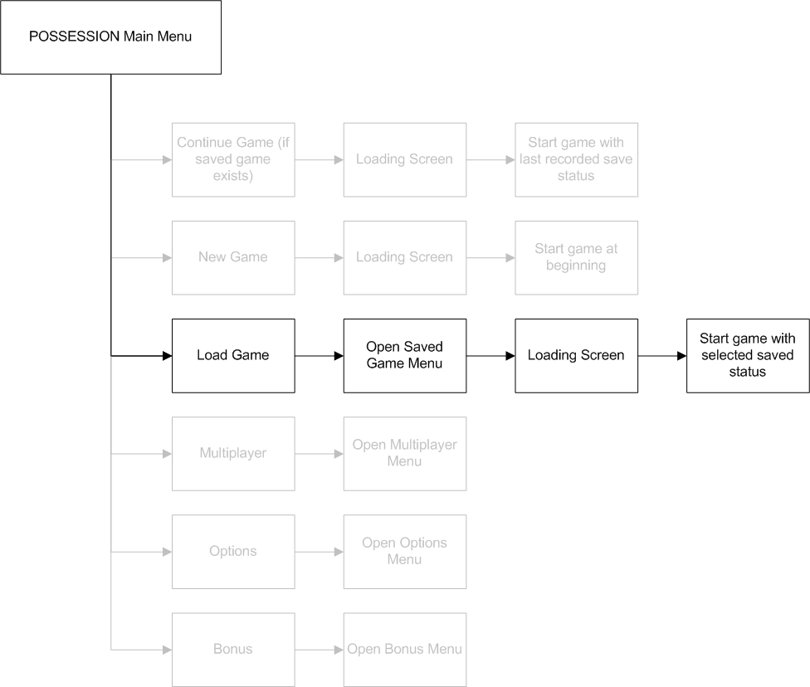

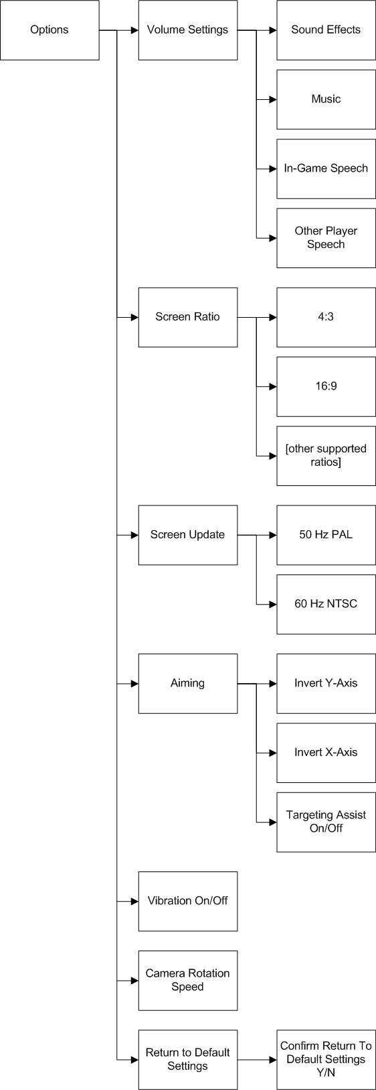
Options Menu

The Options menu allows the user to set their in-game preferences and save them to their profile to be remembered each time they play Possession.

- Volume Settings: The user sets the relative levels of Sound Effects, Music, In-Game Speech and speech from other players in multiplayer modes. This is done via slider bars.
- Screen Ratio: The screen ratios supported by Possession can be selected here. All in-game HUD information and menus adapt to the chosen screen ratio.
- Screen Update: The update frequency of the screen can be selected here. When selecting 60Hz mode, a test screen will be shown to confirm that the user’s viewing device supports this frequency.
- Aiming: The user can invert their x-axis and y-axis settings to suit their personal playing style.
The user can also engage or disengage targeting assistance. This is the function that makes the targeting reticule ‘sticky’ when moved over viable targets. The default setting is On.
- Camera Rotation Speed: A slider bar allows the user to speed up or slow down the speed at which the camera rotates during the game, to suit their preferences.
- Return to Default Settings: If the player is unsure about the settings they have chosen, they can revert to the default settings with this switch. If they choose this option, a warning message appears asking them to confirm the selection before the action is performed.

Bonus Menu

From the Bonus menu the player can view any bonus content they have unlocked in the single-player game. The exact content of the bonus materials will become finalised as the game is developed, but will include the following categories:-

- Multiplayer Avatars: Characters from the single player game can be unlocked and used in multiplayer games. This includes several one off characters hidden away in side missions. From the Bonus menu, the player can bring up the game models of these characters and rotate them with the same controls used in the in-game Map Mode.(see below.)
- Weapons Workshop Parts: Parts that can be used in the Weapons Workshop are unlocked as the player uncovers them in the single-player game. The Bonus menu includes a table showing how many more parts the player has yet to unlock, giving them incentive to go back into the single-player game to find all the pieces.
- Concept Art: Artwork created during development of the game can be viewed full screen from here.
- Movies: This will contain footage of bloopers recorded during the development process, outtakes from voice recording and motion capture sessions, and behind-the-scenes footage from the game’s development.
- Profile Statistics: A large number of statistics are saved for each single-player game, and is used to determine which of the three endings that game will have. Each user profile adds up relevant statistics for the user based on both their single- and multiplayer sessions and these can be viewed here. Statistics include: enemies killed, enemies infected, no. of headshots, no. of kills, no. of time Enslaver killed, largest horde etc.

Multiplayer Game GUI – Detailed Analysis

Multiplayer Menu – General

When the user selects the Multiplayer option from the Main Menu, the whole Main Menu is replaced with the Multiplayer menu.

The Multiplayer Menu gives access to the two types of multiplayer game (live service and system link), the Weapon Workshop (which allows a user to build weapons from parts unlocked in the single-player game for use multiplayer modes involving Survivors), connections to friends (allowing chat and messaging between friends and clans) and normal game options.

The selectable options are as follows:-

- Live Service: This option will only appear if the console is online. If this is the case, the user can host or join an online game, choosing to select a quick match from predetermined settings, or customising their own game options before starting a match with other like-minded players.
- System Link: This option will only appear if the console is linked to one or more other systems. If so, the user can select game parameters or choose to join a game set up on one of the connected machines, and then start a game.
- Weapon Workshop: This takes the user to a special menu from which they can built customised weapons for use in Survivor matches. The weapons can be stored in the user’s saved profile for use in any multiplayer mode that allows customised weapons.

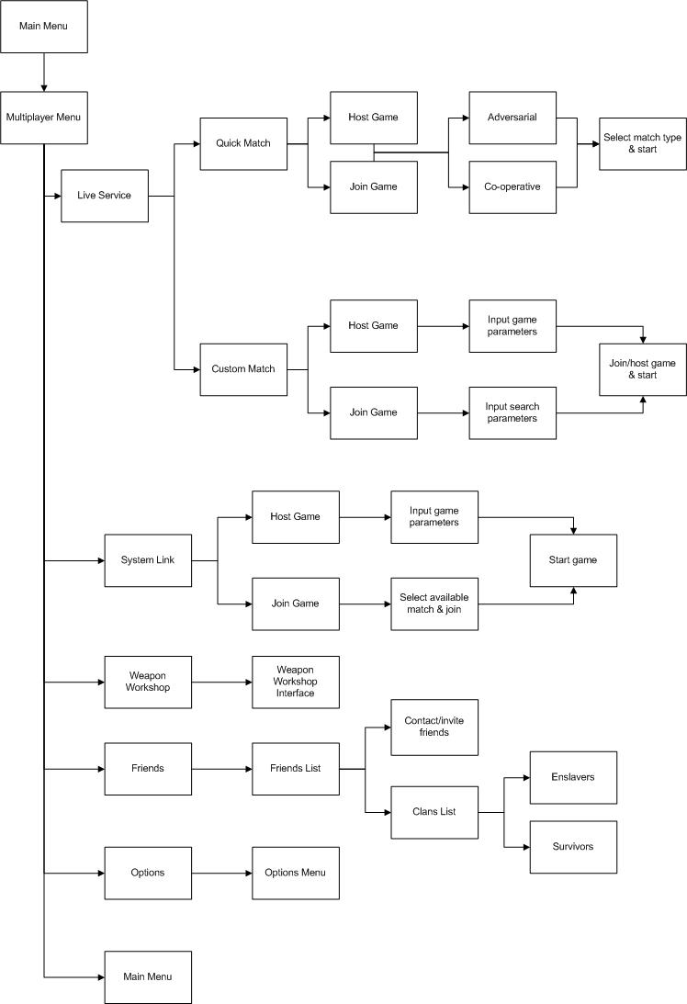
- Friends: The user selects this to contact members of their Friends list to organise play sessions and pass on information or news. The user can also contact any clans they might be involved with, or monitor the progress of rival clans. Clans are split into Survivors and Enslavers, allowing players to create on-line vendettas or challenge particular types of clan.
- Options: This accesses the normal user Options menu, from which volume, screen and control settings can be altered and saved to the user’s profile. See the section above for details of the Options menu.
- Back (Main Menu): This takes the user back to the Main Menu.

Live Service UI

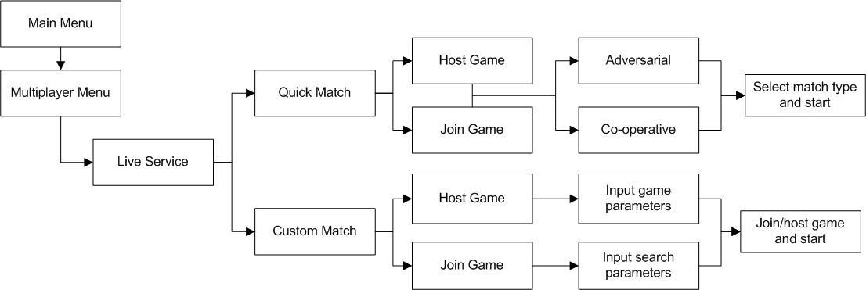

After selecting a live match, the user may decide to customise the on-line experience by setting a sequence of parameters such as number of players, maximum horde size, which map to play on, whether customised weapons are to be allowed, and so on. Alternately, they might just want to start a quick game, selecting a pre-set scenario from a list.

Either way, the player is first asked to either host or join a game.

- A Custom Match’s host chooses the settings that will apply to the current game. Please see “Chapter 10: Multiplayer” for details.
- A Quick Match’s host chooses the pre-set scenario to be used.
- When joining a Custom Match, a user can input search parameters to filter the games that appear in the list, allowing the easy selection of a suitable game.
- Players joining a game only get to select their avatar before the match begins.

After the host has set up the game, the settings become visible to all online players that the host has allowed into the session, and they can then choose to participate.

Players then select an avatar from any that they have unlocked and, once all players have completed their preparations, the host begins the game.

System Link UI

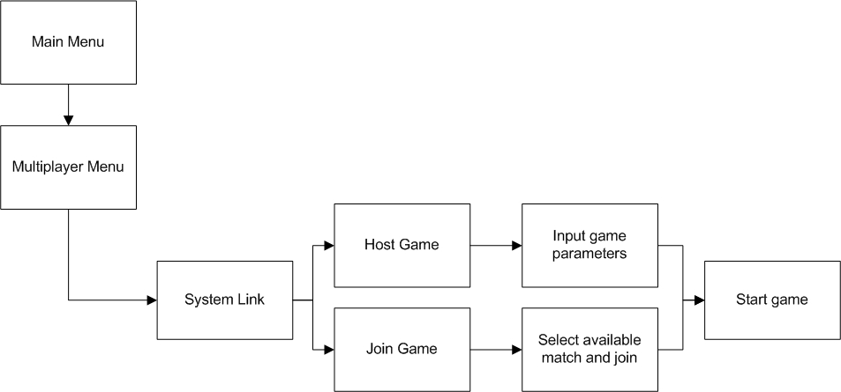

System Link operates in a similar way to Live Service Custom matches. One of the linked players hosts the match, setting the parameters of the session. The other player(s) join this match after selecting their avatar.

Unlike in Live Service matches, the joining players do not need to search for suitable matches. There is only one match available – the one being set up by the host.

Avatar Selection

When playing a multiplayer game as a Survivor, the user chooses their on-screen avatar immediately prior to the start of a match. Once the match begins, they get to equip their character.

Avatar Availability

The user can select an avatar from any that have been unlocked. A selection of common avatars is unlocked right from the beginning of Possession, allowing any user to leap straight into a multiplayer game. These avatars are basic character types – a few Civilians, a regular Police unit and basic Survivors, with male and female variants of each.

Throughout the single-player game, the user can unlock new characters to use as avatars, each with their own unique physical appearance and, sometimes, unique skills or weaponry. Many players will want to collect all of the avatars in the game, and spotting another player controlling an avatar not in the player’s collection will inspire them to scour the single player mode to find and unlock it.

When playing as the Enslaver, the user does not get to choose their avatar. However, the host can set what Stage the Enslaver is at, determining the physical appearance and abilities of the Enslaver, and which zombie types the Enslaver player has access to.

Team

While choosing their avatar, a user also gets to select their team, by clicking on the available team logos.

The avatar model will update to show which team it is on. This will usually be a change in colour of some part of the avatar’s clothing, such as a shirt or helmet.

Equipment

After selecting an avatar, the game begins. Users playing as Survivors must then set up their equipment. This includes the power up items the avatar possesses and the weapon(s) it is carrying.

- A character sheet screen appears in which the character is displayed on the right of the screen, overlaid with boxes representing equipment slots.
- On the left of the screen are boxes containing the available equipment types, which are determined by the host and possibly by the avatar in use. Some items take up more than one box, indicating that the item is large and therefore a player can carry less of them.

If the player has built customised weapons in the Weapon Workshop, these will be selectable from this screen, assuming that the host has allowed the use of these potentially powerful weapons.

Weapons Workshop

Players can, in their own time, create customised weapons in the Weapons Workshop. This process is summarised below - full details are given in “Chapter 10 – Multiplayer”.

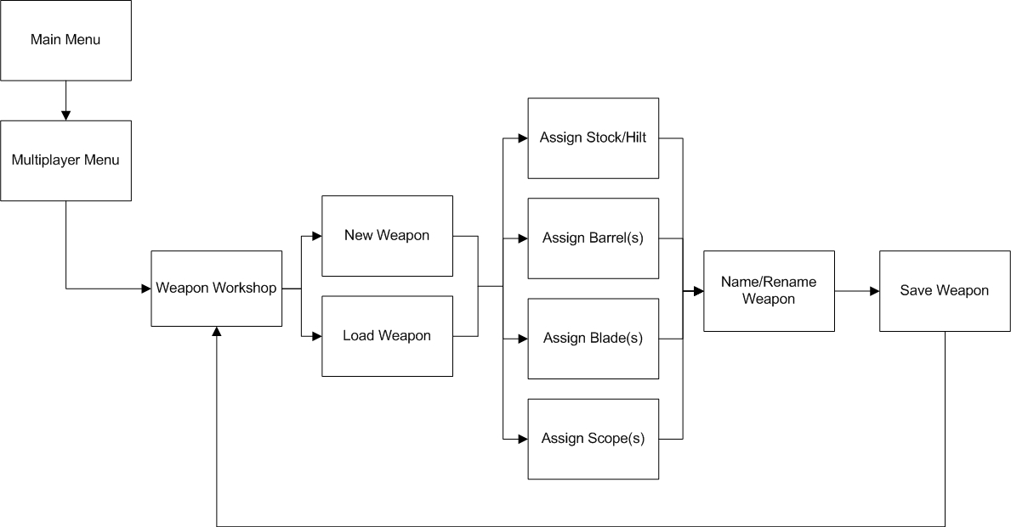

The Weapons Workshop screen contains a grid, each slot of which represents a part of the final weapon. Each part added can also add new slots that the player can use, offering a huge amount of customisation:-

- Stock/Hilt: This is the handle or grip of the weapon.
- Barrel: This contains the firing chamber, if relevant.
- Blade: This can include actual bayonets or simple household knives strapped to the barrel.
- Scope: Helps to increase the accuracy of the weapon.

Available and appropriate parts appear below the construction grid. This list updates with every piece added to the weapon – some parts can only be attached to certain others, so any inappropriate parts disappear from the list.

Upon completing a weapon, the user can name it and save it to their profile, allowing them to use it in relevant multiplayer games.

The number of slots used by a weapon is also saved – among the settings for a multiplayer match, the host player can limit the number of slots allowed in a game, effectively ruling out the more powerful weapons.

If a player hits the back button (the ∆ or Y button) after modifying a weapon, a warning will pop up to indicate that the changes will be lost. The player is given a chance to save their changes or exit the Weapons Workshop without saving.

The Weapons Workshop can be accessed at any time. The console does not have to be linked to another console or online to access this feature.

Friends Menu

This menu allows a user to view their friends list, see who is online and contact them, or leave them a message if they are not online. Using this feature, users can organise play sessions and enhance their online gaming experience by sharing it with friends.

A scrolling list of the user’s contacts appears, along with their relevant statistics and whether or not they are online. The list can be switched to show either individual friends or a list of clans.

- Contact/Invite: The user selects this option to open a dialogue with selected friends or clans. If the invite is accepted, the player is then given an option to join a friend or clan’s game in progress or host a new game. This second option takes the user to the standard Host Game menu described below.

Clans can be Enslaver Clans or Survivor Clans. Players will form rivalries with other clans, and challenge them to matches, proving themselves against their rivals by taking their maps, beating their members and having their victories registered online for all to see.

Host Game Menu

This menu is only accessed by the host of a multiplayer match. It contains all the settings relevant to creating an online game, from the number of players allowed, to the equipment available in the match.

Once a match has been created, the host can save it to their storage device so that they can start a similar game another time without having to set all of the options again.

Firstly, the host determines whether to begin an Adversarial game or a Co-operative game and selects the type of game it will be (Deathmatch, Survivor vs. Enslaver etc.) Game types are described in “Chapter 10 – Multiplayer”.

- Select Multiplayer Map: The host decides which map to play on. Certain maps only fit certain match types.
- Team Play: If the host switches this option to Yes, players will work together in the teams they choose on the Avatar Selection screen. If the option is set to No, the match will be every player for themselves.
- Number of Player Lives: This determines the number of times a player can be respawned before being removed from the current match/round.
- Player Maximum Health: The host determines the maximum amount of health each player can have. If the Enslaver is active in the match, his health is determined by the Enslaver Stage chosen.
- Max. Number of Players: This determines how many players can take part in the session.
- Max. Number of Zombies: This determines the size of the Enslaver player’s horde, or the maximum number of zombies that can be released in a level.

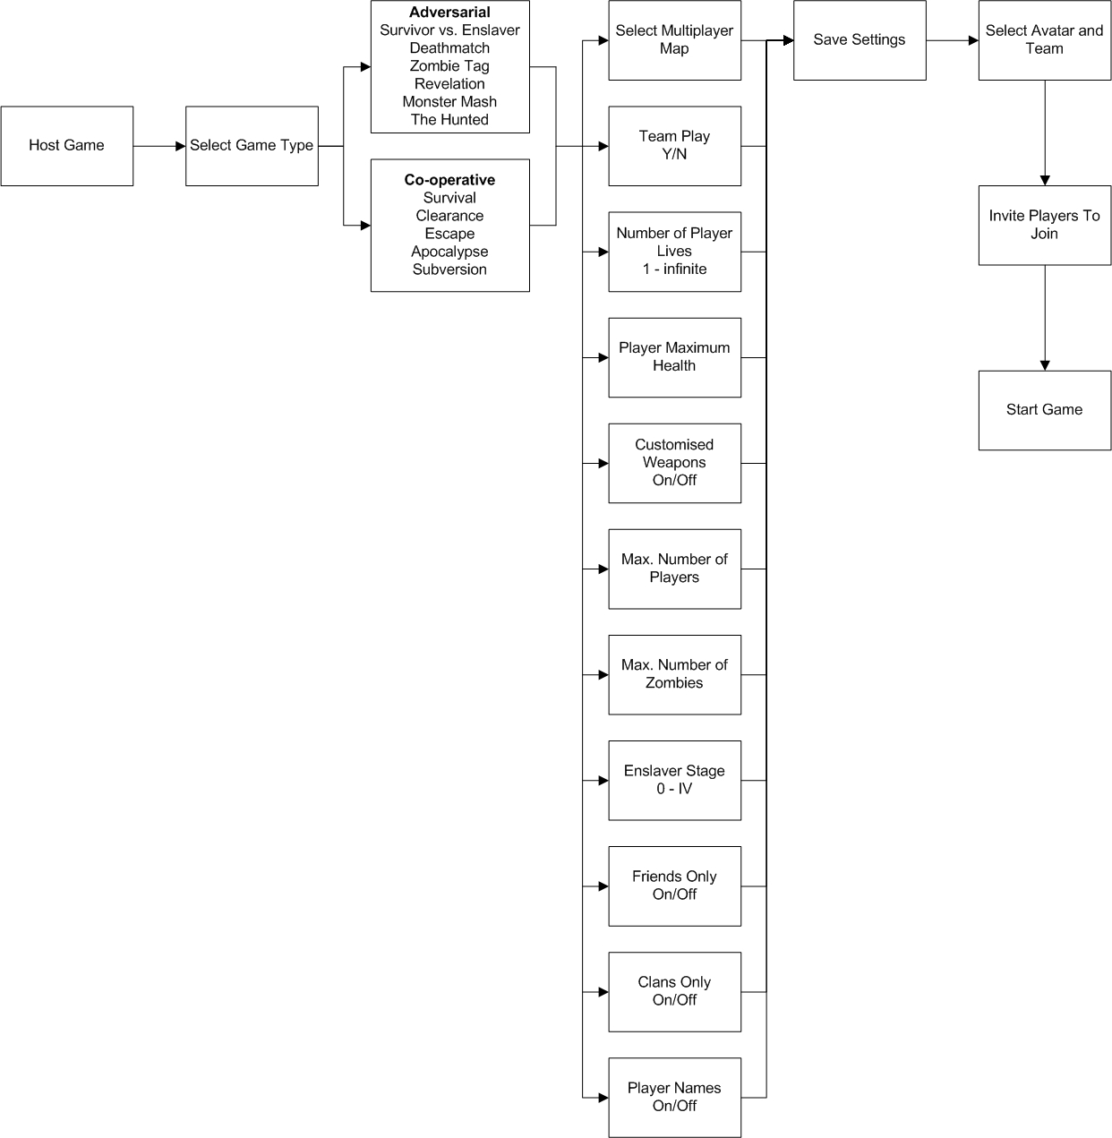

- Enslaver Stage: The host sets which level of evolution the Enslaver begins at. 0 is the Enslaver as he has just broken out of the initial lab (Shamblers only), whereas Stage IV is the Enslaver at his maximum level of evolution, with access to all zombie mutations. This option only appears if the Enslaver is active in the selected match type.
- Friends Only: This option will make the host’s game only available to members of their friends list.
- Clans Only: This option will make the host’s game only available to online clans, allowing rival clans to quickly find and challenge each other.
- Player Names: This toggles whether player names will appear above their avatars or not.

Pause Menus
The Pause menus appear when the player hits the ‘Select’ (‘Back’ on the 360) button at any time after the start of a game. There are three Pause menus depending on when the button is pressed:-

- Pause Game Menu: If the game is paused during game-play, this menu appears, allowing the player to save or load games, change game options or quit out to the Main Menu.
- Pause Cutscene Menu: If a cutscene is playing, the player can pause it and then choose to continue or skip to the end of the cutscene.
- Multiplayer Menu: This allows users to alter their settings during a multiplayer game.

Pause Game Menu

The normal Pause menu contains the following options:-

- Save Game: The game lists the player’s saved files and also a ‘New Save’ slot, which is selected by default. The player chooses to save in this new slot, or save over one of their other files. If they choose this second option, a warning will appear to ask the player to confirm the overwriting of the older file.
- Load Game: The available saved files appear and the player can select one to load. A warning will appear to alert the player that loading a saved game will lose any unsaved data from the current game and ask them to confirm their choice.
- Options: This opens up the standard Options menu described earlier (Section 8.2.5).
- Quit Game: The player can quit out to the Main Menu. If they choose this option, a warning will appear to alert the player that quitting the game will lose any unsaved data from the current game and ask them to confirm their choice.
Note: Details of saving games is given in “Saving Games” below.

Pause Cutscene Menu

This menu contains only two options:-

- Continue: This unpauses the cutscene and resumes playing it as normal.
- Skip: This skips to the end of the cutscene to allow the user to immediately continue playing. Any game settings altered by an in-engine cutscene (e.g. character positions, objects or terrain moved/destroyed etc.) are correctly set to the status they would have inherited through the cutscene.

Note: The ‘Skip’ option is greyed out and cannot be selected if the cutscene has not been seen before. Once a cutscene has been viewed once, this fact is saved to the user’s profile, and that cutscene can then be skipped on future viewings.

Pausing In Multiplayer

A player may want to change some of their settings during a multiplayer game. Hitting the Pause button brings up the Multiplayer Menu – the main difference here is that the game doesn’t stop playing, so the player must hide somewhere safe while changing options.

- Options: This brings up the Options menu, so the user can change volume settings etc.
- Quit Game: The player can log off a game in progress. A confirmation window will open up – if the player confirms their selection, their avatar will fall down in despair and take their own life!

Map Screen
The Map Screen is accessed by pressing the ‘Back’ or ‘Select’ button at any time during gameplay (not during cutscenes.)

The Map Screen shows a three-dimensional model of the current District, with overlays that reveal certain important items of information to the player:-

- The Enslaver’s current location
- The locations of zombies and enemies within the Enslaver’s perception range.
- The locations of enemy units outside the Enslaver’s perception range, if the player has accessed the relevant enemy communications. For example, accessing police communications reveals information about police deployment in the current District.
- The locations of major objective points – bridges, Prometheus lab facilities (if known), etc.
- The locations of secondary objective points - police stations, fire stations, power plant etc.

The following controls can be used on the Map Screen:-

- Left Analogue Stick: Pans the map left, right, up and down.
- Right Analogue Stick: Rotates the map left and right, and zooms in and out.
- ‘Back’/’Select’ Button: Exit the map and return to the game.
- ‘Start’ Button: Move view focus to Enslaver’s location.

Note: Please refer to “In-game Player Map” in Chapter 7 for more details.

Saving Games
As with all elements of Possession the loading and saving components need to be efficient, unobtrusive, and highly polished, while at the same time complementing the nature of the game’s design. There are 2 different save game components:

- User profiles: These allow multiple users to each have their own configuration data that is loaded up on boot-up.
- Game saves: These are used to ‘snapshot’ the state of the game for the current user

User Profiles

Possession will make use of user profiles in order to store the main game options, allowing multiple players to have their own preference settings saved on a single console. These user profiles will hold all of the settings and preferences that are outside of the main game, such as inverted y-axis, audio levels, customised weapons and secrets unlocked. As the game initially boots up the player simply selects the user file that they wish to load, or they can choose to create a new one of a different name.

Game Saves

The open-ended design methodology that has been used by Possession is a system that ultimately gives the player a high degree of freedom within the City. With such a design architecture it is fully expected that the more conservative players will wish to save their progress regularly, allowing them to try out a certain plan of attack but to then choose to reload if the strategy fails, or even simply to explore the various choices one by one.

Game Saves Design Goals:

The goals are therefore:-

- To ensure that the save mechanism can be called at any time during the game (with the exception of cut-scene sequences.)
- To ensure that the save game mechanism is highly efficient and intuitive.
- To allow multiple save slots during the same period of gameplay.
- The game saving needs to be unobtrusive by either saving in less than 5 seconds, or by saving in the background while the game continues to play.
- To auto-save when major elements of the game have been completed, or to prompt the player to save at these points.

Saving a Game

The player can save the game at any time except during a cutscene, using the following quick process:-

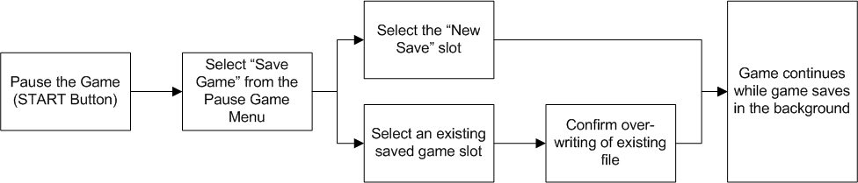

While the game saves in the background, an icon appears on the HUD to show that the storage device is being accessed. The first time that the player saves a game, a text box will appear showing this icon and warning the player not to interfere with the system (by removing memory or control devices, or turning off the power) while the icon is visible.

Save Slot Info

When viewing the save games, the user will be presented with an ID, the time and date of the save, and an image of the last frame rendered before the save occurred.

Save Game Prompts

Although much of Possession is non-linear, there are still major events and bottlenecks within the city that are valid save points. Rather than use an auto-save mechanism here, the player is instead prompted to save their game manually.

This is to prevent the game from automatically saving a file over one already in existence, and potentially frustrating a player who had wanted to try the previous stage of the game using a different strategy.

Save Game Info

Due to the high level of destructibility in Possession, coupled with the complexity of the physics, it is unrealistic to expect the facility to save the state of every single entity within the game. Neither can the positions of every blood splatter, charred surface and other effects that have been generated while playing the game be saved.

The game therefore saves general information about the player’s actions; for example, the number and type of dead bodies in a zone. Upon reloading the game, a similar number of dead bodies are generated in that zone to represent the events that occurred there. For more details of this system, please refer to “Fading Of Dead Bodies” in Chapter 3.

There are of course some fundamental elements that will always be saved. They are:-

- The position of the Enslaver and his current control/animation state.
- The Enslaver’s current mutation level, his health, and when he was last hit (if health is not at maximum.)
- The numbers and types of zombies within his horde, their current positions and AI states.
- The current stack of zombie commands that are active.
- Essential level data – this is a list of flags and IDs for the states of individual buildings and whether particular events have occurred or not.
- The enemies that are currently engaged with the Enslaver or his horde, and their own AI states.
- The date, time and a miniature screenshot of the last frame rendered.


