

Chapter6

Armour, Weapons and Equipment

Chapter6
Armour, Weapons and Equipment
ARMOUR
Standard encounter suit
Light Armour
Power Assisted suit
Power Assisted Heavy suit
EVA suits
WEAPONS
PISTOL
RIFLE
GAUSS RIFLE
LASER RIFLE
FLAME THROWER
FLAME THROWER VARIANT (helium)
PROXIMITY GRENADES
GRENADES
STUN GRENADES
ROCKET LAUNCHER
DEMOLITION CHARGES - used as grenades
PLASMA PISTOL
HEAVY PLASMA RIFLE
FUSION PACKAGE DELIVERY
GUIDED MISSILE LAUNCHER
ALIEN GRENADES
Equipment
MEDIKIT
TRANSPORTER
DATA RETRIEVAL HAND HELD UNIT
SENTRY GUN
Robotic Units
GRAV TANK ROCKET LAUNCHER
FLYING SCOUT DRONE
MOBILE STORE
REACTOR REPAIR UNIT
BULKHEAD CUTTER
mission objective pick-ups
GIZMOS
DIMENSION GATE DEVICE
Equipment availability breakdown by mission number

ARMOUR

The armour suits are constructed from combining elements of power loaders, hydraulic systems and any thing useful that came to hand. Based on standard environmental protection suits, the power loader exoskeleton gives the user increased carrying capacity, allows the mounting of weaponry on to the suit, and can increase the speed that a unit can travel around in the world.

The armours are not smooth in the fashion of Space Hulk Terminators or the previous X-Com armours, rather they are irregular with the components being clearly visible.

The speed a unit can move is related to the protection level of suit. High protection = low mobility.

There are 5 types of suit:

Standard encounter suit.
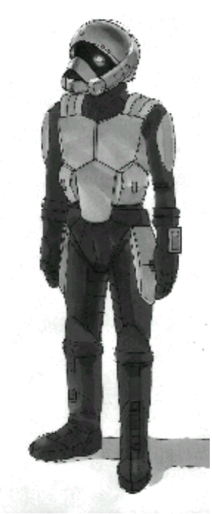

Provides atmosphere protection and very little else. Standard personal inventory slots, player starts with this equipment.

Light Armour

Standard encounter suit, which has metal plates strapped over it.

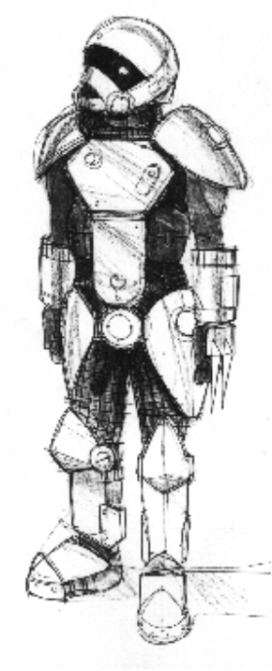

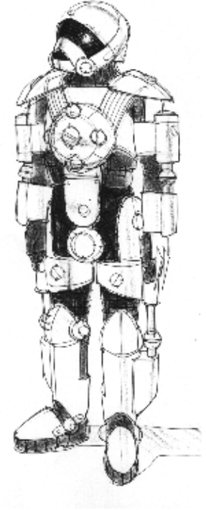

Power Assisted suit.

Fast moving, lightly armoured - used for scouting and fast strikes.

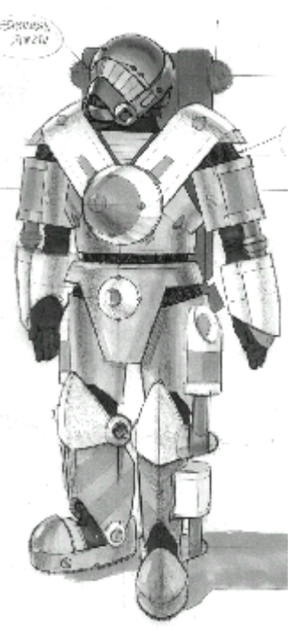

Power Assisted Heavy suit. -

Increased ammo carrying capacity & more inventory slots, also heavy armour protection for trooper so low mobility (the heavy tank of personal armours)

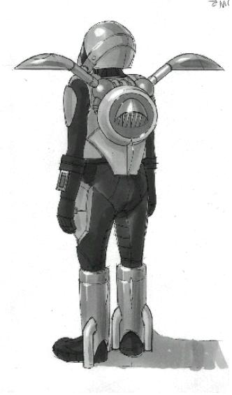

EVA suits. -

flying capability, little/no protection from enemy attacks, but this is the fastest of the armour types.

WEAPONS

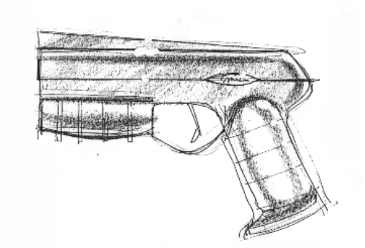

PISTOL

Alien or X-COM: X-Com
Max. Polygon Count: 250
Muzzle Flash: White
Projectile: Large and white accompanied by explosive
concussion sound
On Impact: Bullet impact effect
Damage: TBD
Fire Rate: 1 per second

Description: Standard projectile weaponry, less accurate than rifle.

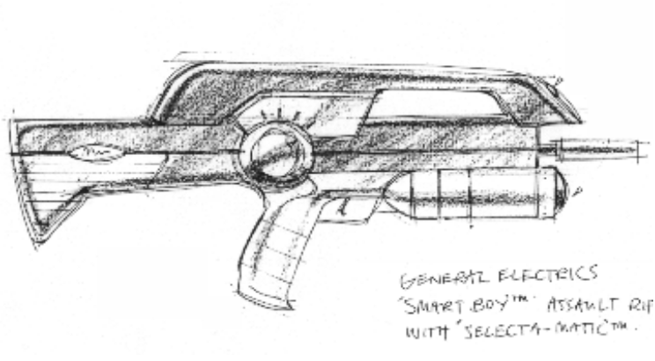

RIFLE

Alien or X-COM: X-Com
Max. Polygon Count: 250
Muzzle Flash: White
Projectile: Very large, white, creating ripping sound effect.
On Impact: Bullet impact effect
Damage: TBD
Fire Rate: 3 per second

Description: Standard projectile weaponry with increased accuracy
over the pistol.

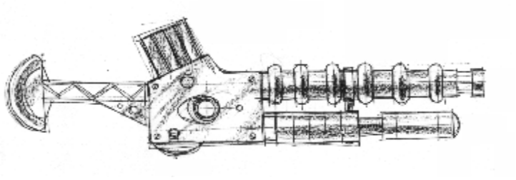

GAUSS RIFLE

Alien or X-COM: X-Com
Max. Polygon Count: 250
Muzzle Flash: Blue flash
Projectile: Small slug of metal, accompanied by electric discharge
sound effect
On Impact: Bullet impact effect
Damage: TBD
Fire Rate: 4 per second

Description: Using super conducting transformers, this gun
generates a powerful magnetic field, which propels the magnetically charged projectile to very high muzzle velocities. The next generaton of projectile weaponry.

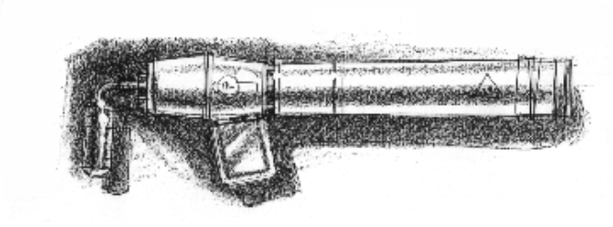

LASER RIFLE

Alien or X-COM: X-Com
Max. Polygon Count: 250
Muzzle Flash: Red
Projectile: Bright red bolt
On Impact: Burn impact effect
Damage: TBD
Fire Rate: 5 per second, pause for 1 second

Description: Utilising the portable laser cutters initially destined for
use excavating the Cydonia site, these weapons have been stripped of their excess weight to allow them to be wielded by the units engaging the alien forces. Emitting in the higher EM frequencies, these weapons deliver a highly powerful beam of coherent energy. However the number of discharges is limited to the amount of energy that can be stored within the energy cell. These cells can supply a number of discharges, and can be recharged on the Patton.

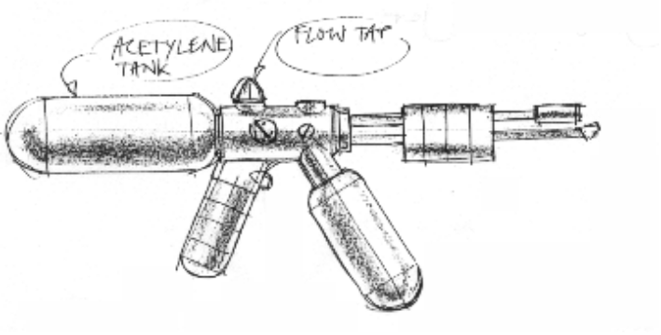

FLAME THROWER

Alien or X-COM: X-Com
Max. Polygon Count: 250
Muzzle Flash: Bright yellow flicker
Projectile: Animating ‘fire’ mesh model
On Impact: Blooms into a large f ireball/ burn impact effect
Damage: TBD
Fire Rate: Constant

Description: Derived from the oxyacetylene welding equipment, the
weapon is readied for use by pressurising the liquid through means of a conventional fluid pump. The flammable mixture is ignited through an ignition flame mounted in front of the weapon’s muzzle. The pressurised fluid has an effective range of 10 feet, limiting this weapon to short range uses. It does however deal a devastating level of damage to both organic and non-organic materials. Care should be taken not to use this on equipment sensitive to mission objectives

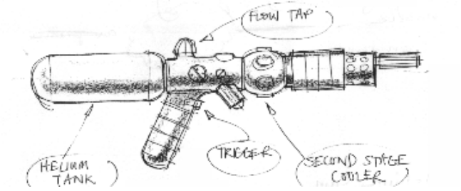

FLAME THROWER VARIANT (helium)

Alien or X-COM: X-Com
Max. Polygon Count: 250
Muzzle Flash: Dim blue/white
Projectile: Animating ‘cold’ mesh model
On Impact: Cold impact effect
Damage: TBD
Fire Rate: Constant

Description: Uses liquid Helium as opposed to flamer. New
insulation techniques and polymer materials allow a jet of liquid Helium to be sprayed at a target.

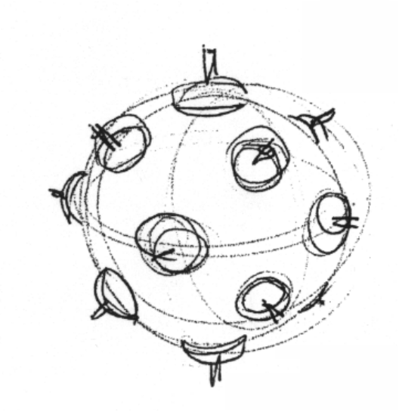

PROXIMITY GRENADES

Alien or X-COM: X-Com
Max. Polygon Count: 250
Muzzle Flash: N/A
Projectile: Polygon model
On Impact: Standard explosion
Damage: TBD
Fire Rate: 1 per 4 seconds

Description: Utilising the fuel required for the chemical thrusters,
these grenades are highly destructive. However, due to the unstable nature of the fuel, they must be handled with extreme care. These items are best deployed to secure areas, as the pressure increase caused by treading on these unobtrusive items will cause them to detonate.

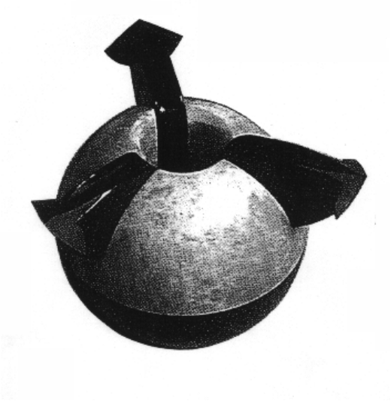

GRENADES

Alien or X-COM: X-Com
Max. Polygon Count: 250
Muzzle Flash: N/A
Projectile: Polygon model
On Impact: Standard explosion
Damage: TBD
Fire Rate: 1 per 2 seconds

Description:
The destructive capability of thse items comes mainly from the shrapnel mixed with the explosive fluid. Ensure that all personnel are evacuated before use of this item to minimise the possibilities of injury.

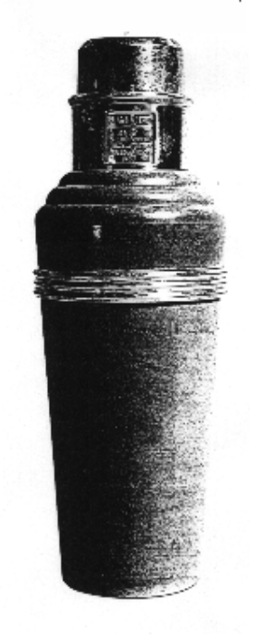

STUN GRENADES

Alien or X-COM: X-Com
Max. Polygon Count: 250
Muzzle Flash: N/A
Projectile: Polygon model
On Impact: Light flash but no fireball
Damage: TBD
Fire Rate: 1 per 2 seconds

Description: Concussive explosion, with little/no fragmentation to
stun alien units for interrogation. Utilising the same design as the fragmentation grenades, these items have no shrapnel payload, making their bark worse than their bite.

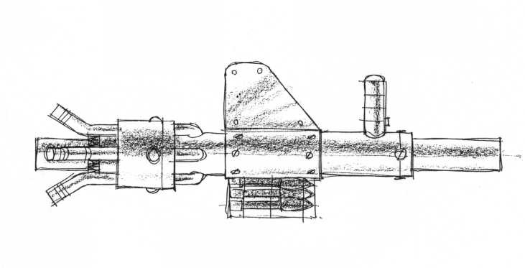

ROCKET LAUNCHER

Alien or X-COM: X-Com
Max. Polygon Count: 250
Muzzle Flash: Bright yellow
Projectile: Polygon model rocket, with fire trail
On Impact: Standard explosion
Damage: TBD
Fire Rate: 1 per second

Description: Using a compressed gas charge and a tapering
barrel, combined with a soft metal flange around the rockets to increase the muzzle velocity of the weapon. The recoil of the weapon is balanced through the release of pressurised gas from the rear of the unit, reducing the physical shock that would otherwise be associated with the firing of this weapon.

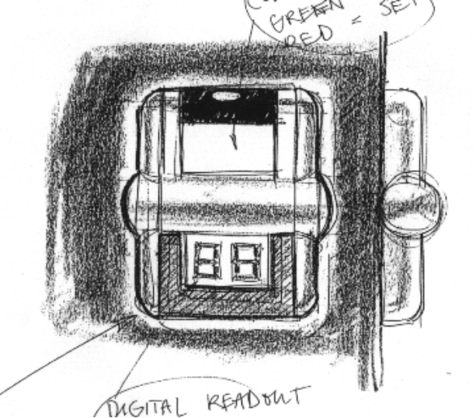

DEMOLITION CHARGES - used as grenades

Alien or X-COM: X-Com
Max. Polygon Count: 250
Muzzle Flash: N/A
Projectile: Polygon model
On Impact: Large standard explosion
Damage: TBD
Fire Rate: 1 per 5 seconds

Description: Constructed from demolition charges, these items are
fitted with proximity sensing circuitry linked to dthe detonation circuitry. Once primed these devices cannot be disarmed except by detonation. Extreme caution and forethought is required when deploying these items.

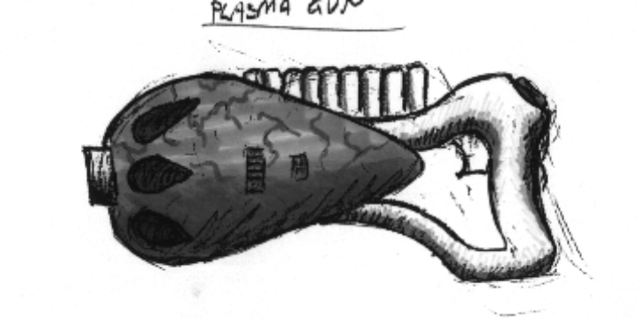

PLASMA PISTOL

Alien or X-COM: Alien
Max. Polygon Count: 250
Muzzle Flash: Bright green
Projectile: Small bright green ball.
On Impact: Burn impact effect
Damage: TBD
Fire Rate: 3 per second

Description: The basic form of armament used by the alien scum.
Utilising a small quantity of Elerium within each clip, we have no methods available to replicate these weapons and ammo.

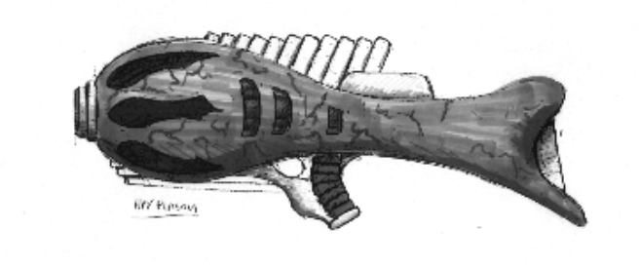

HEAVY PLASMA RIFLE

Alien or X-COM: Alien
Max. Polygon Count: 250
Muzzle Flash: Intense green
Projectile: Medium size green ball with a white core
On Impact: Burn impact effect
Damage: TBD
Fire Rate: 3 per second

Description: Very powerful, this is a more advanced version
of the plasma beam technology. This weapon is deadly in the hands of the alien troopers. Again we have no method of board the Patton to manufacture the ammo for this weapon.

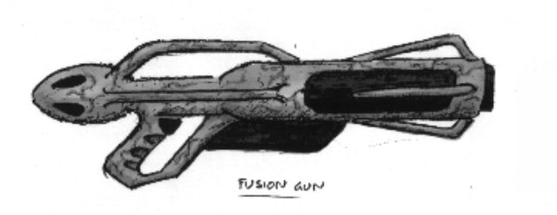

FUSION PACKAGE DELIVERY

Alien or X-COM: Alien
Max. Polygon Count: 250
Muzzle Flash: Intense blue
Projectile: Pin-prick of bright blue ‘lens-flare’ type shot that moves
very fast
On Impact: Very big, blue-fire explosion
Damage: TBD
Fire Rate: 1 per 2.5 seconds

Description: Parcel of anti-matter contained in a magnetic field.
This is then projected towards the target. Parcel microcomputer sets up a containment field around target 10 milliseconds before impact to prevent matter/anti-matter reaction encroaching TOO far from target.

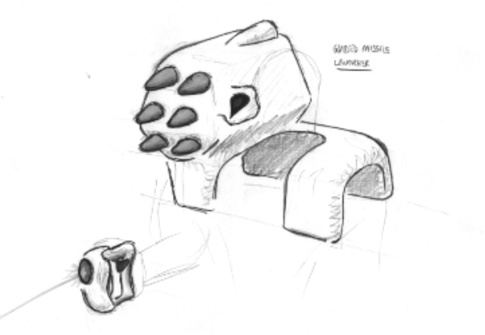

GUIDED MISSILE LAUNCHER

Alien or X-COM: Alien
Max. Polygon Count: 250
Muzzle Flash: White
Projectile: Polygon model of projectile
On Impact: Large standard explosion
Damage: TBD
Fire Rate: Individually controlled

Description: Shoulder mounted and containing a high explosive
payload, the launcher is guided by a human operative with a hand held guiding unit. On board CCD devices tuned to both the visible and IR wavelengths are fed back to the combat personnel who then, in effect, fly each missile to it’s target. Using gravity field control systems this device has a variable velocity and altitude. Unfortunately, low velocity use of this weapon severely reduces it’s offensive strike capability, as any vigilant opponent has sufficient time to shoot the device down.

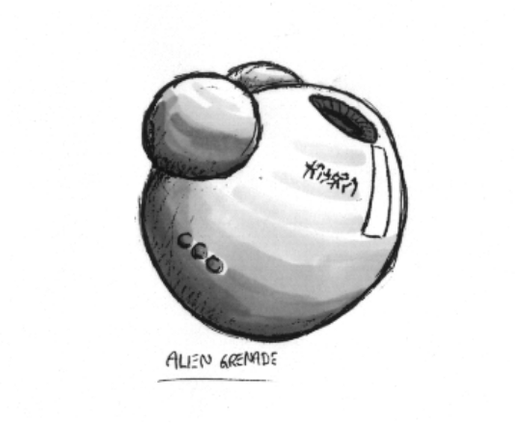

ALIEN GRENADES

Alien or X-COM: Alien
Max. Ploygon Count: 250
Muzzle Flash: N/A
Projectile: Polygon model
On Impact: Large, conventional explosion
Damage: TBD
Fire Rate: 1 per 2 seconds

Description: Same as terrestrial grenade but more powerful.

Equipment

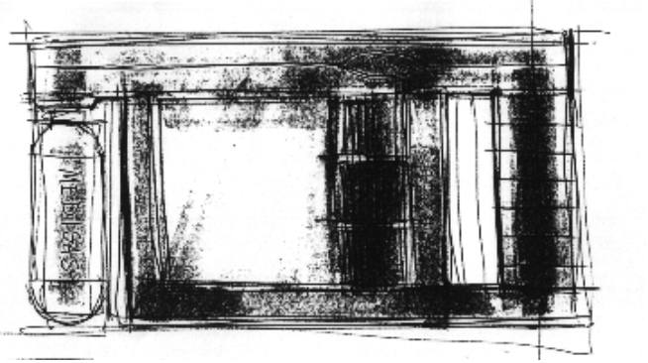

MEDIKIT

Alien or X-COM: X-Com
Max. Ploygon Count: 250

Description: One of the most useful pieces of equipment
available, this unit is capable of diagnosing and treating a bewildering array of battle field injuries. In addition to it’s healing capabilities the Medikit is also capable of delivering anti-fatigue stimulants and pain killers.

The medikit can only be used a limited number of times, with each use adding 10 to the unit’s ‘current hit point’ statistic. The health for a trooper cannot exceed the amount of health defined by that unit’s ‘health’ statistic (see character statistic section for more detail). This device is held with both hands and self administered. The screen display on the device shows 3 levels rising as aid is administered.

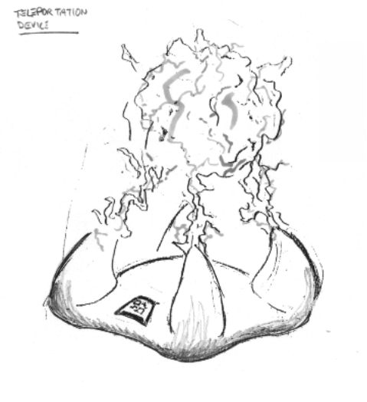

TRANSPORTER

Alien or X-COM: Alien
Max. Ploygon Count: 250
Activation Effect: Bright ‘activated’ texture maps, possible pulsing glow
Deportive Effect: Player mesh shrunk to ‘pin-prick’ instantly, rotating
‘electric field’ texture cylinder appears and vanishes
Arrival Effect: As above except that the player mesh is taken from
‘pin-prick’ to full size.
Character Effect: Character view point whites out immediately upon
usage and slowly fades back in upon reaching destination. This leaves player blind, and therefore very vulnerable, for two seconds.

Description: This consists of two parts which are placed down within
the world. When transmitting, the activated station decomposes the target to subatomic particles, the charge, spin and location of which are recorded. They are finally transmitted to the receiving station thus allowing the recreation of the target at that destination. This technology relies on highly complex data multiplexing routines to enable the transmission of the data with sufficient speed.
The transporter pads are paired as a transmitter and receiver station. Before deployment the pads are keyed to a specific data encryption/decryption key. If multiple stations exist within a mission site, each transmitter will only respond with it’s mate. The transmitter and receiver are effectively two pieces of equipment, each being a different colour to allow idenfification within the 3D world.

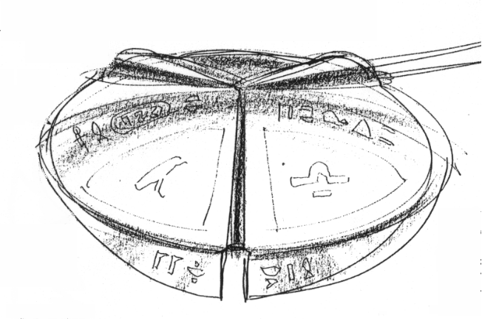

DATA RETRIEVAL HAND HELD UNIT

Alien or X-COM: X-Com
Max. Ploygon Count: 250

Description: A dinner plate sized ascidian device which is interfaced
with the subject device via extendable, many jointed antenna like probes. Ice cracking programs for retrieving information from alien computers

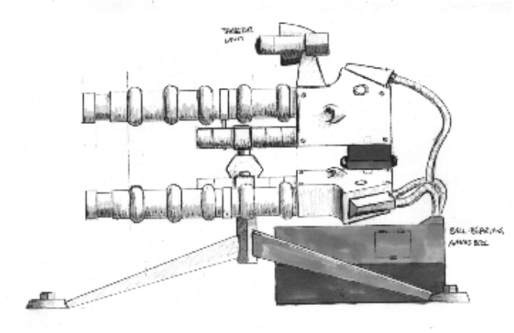

SENTRY GUN

Alien or X-COM: Alien
Max. Ploygon Count: 250
Muzzle Flash: Repeated blue flashes
Projectile: Ball bearing (polygon model)
On Impact: Conventional projectile impact
Damage: TBD
Fire Rate: Phenomenal

Description: Combining the technology utilised in Gauss Weaponry
with state of the art Motion & Infra Red sensing circuitry, these weapons can be deployed in a combat environment, allowing areas to be secured, with the mininmum of personnel. Once armed these devices are capable of delivering lethal levels of fire power to secure areas without the use of any personnel.

Care must be taken during combat missions as the equipment can ony be approached from the rear to disarm the sensing equipment.

Robotic Units

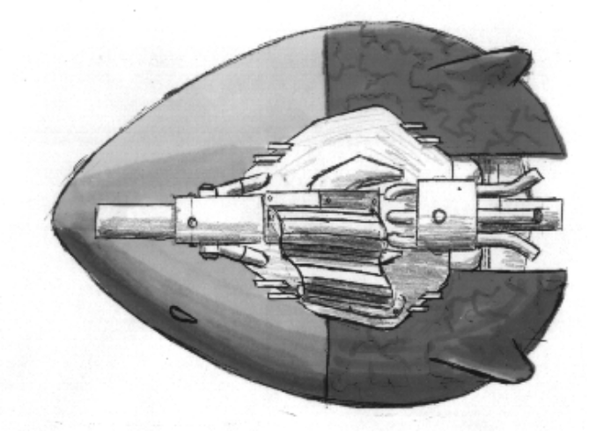

GRAV TANK ROCKET LAUNCHER

Alien or X-COM: Alien
Max. Polygon Count: 450
Muzzle Flash: Bright yellow
Projectile: Rocket
On Impact: Explosion
On Death: Blown to bits
Fire Rate: Once a second

Description: Floating anti-grav platform with standard gas projected
rocket launcher firing mechanism added. Much larger ammunition capacity. Navigation and AI circuitry built in. Comes from alien Grav. Unit, rocket launcher and reactor repair unit spare parts.

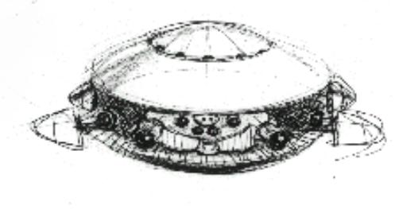

FLYING SCOUT DRONE

Description: A lightly armoured flying TV Camara

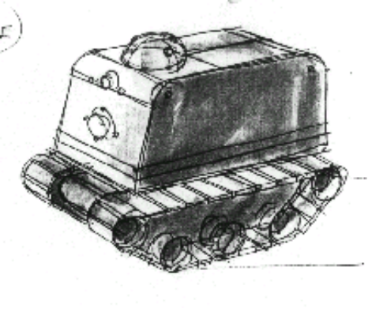

MOBILE STORE

Description: Mobile storage unit, which cannot use any armaments.
It just carries equipment around, and is also useful as a mobile source of cover.

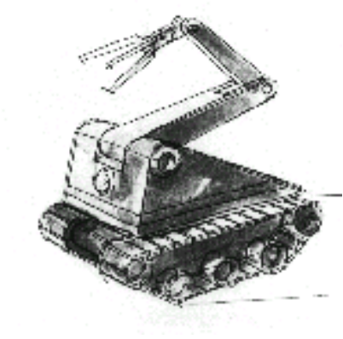

REACTOR REPAIR UNIT

Description: A mechanical unit which can exist in hostile
environments. It is armoured and has some degree of intelligence.

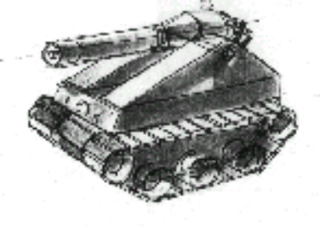

BULKHEAD CUTTER

Description: Permanantly equiped with an industrial laser cutter, this
unit will allow internal bulkheads and doors to be cut through, negating the need for door access codes.

mission objective pick-ups

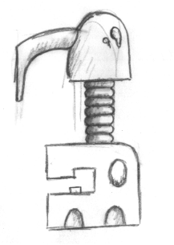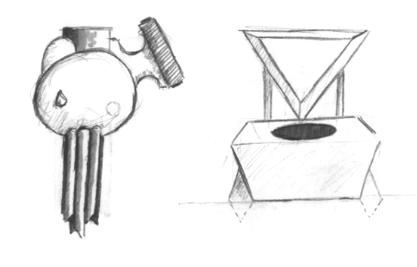

GIZMOS

Alien or X-COM: Alien
Max. Ploygon Count: 250

Description: Three alien components for space ship. Player has to
retrieve in Mission 20 in order to repair captured craft

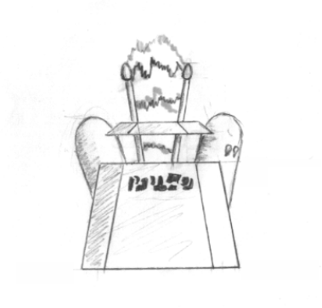

DIMENSION GATE DEVICE

Alien or X-COM: Alien
Max. Polygon Count: 250

Description: To be retrieved by player in Mission 11. Vital
prototype of Sectoid’s Dimension Gate Technology.

Equipment availability breakdown by mission number
Item | Category | Type | Mission No. Found
X-Com
Standard Encounter Suit | X-Com | Armour | Always
Demolition Charges | X-Com | Equipment | Always
Medikit | X-Com | Equipment | Always
Motion Scanner | X-Com | Equipment | Always
Normal Grenade | X-Com | Grenade | Always
Stun Grenade | X-Com | Grenade | Always
Laser Rifle | X-Com | Gun | Always
Pistol | X-Com | Gun | Always
Rifle | X-Com | Gun | Always
Flying scout drone | X-Com | Robot | Always
Flame thrower | X-Com | Gun | 1
Light Non powered armour | X-Com | Armour | 2
Liquid Helium Thrower | X-Com | Gun | 3
Mobile Store | X-Com | Robot | 4
Light Powered armour | X-Com | Armour | 6
Rocket Launcher (Gas Projected) | X-Com | Gun | 7
Reactor Repair Unit | X-Com | Robot | 9
Gauss Weapon | X-Com | Gun | 10
Heavy power suit | X-Com | Armour | 11
Bulkhead Cutter | X-Com | Robot | 14
EVA suit | X-Com | Armour | 16
Sentry Gun | X-Com | Equipment | 17
Grav Tank Rocket Launcher | X-Com | Robot | 19
Alien Items
Plasma Pistol | Alien | Gun | 1
Alien Grenades | Alien | Grenade | 2
Dimension gate device | Alien | Pickup | 11
Heavy Plasma | Alien | Gun | 13
Rocket Launcher (Remote Controlled) | Alien | Gun | 15
Fusion Package Gun | Alien | Gun | 18
3 Alien components for ship | Alien | Pickup | 20
Transporter Pad | Alien | Equipment | 20
Ascidian Equipment
Data download unit | Ascidian | Equipment | 1
Data chip | Ascidian | Equipment | 8,21

In the above table, the mission number found entry indicates that after the player completes that mission, the UFOpaedia / mission debriefing entries will be available to the player.

