XCom

Alliance

Episode B2
Dark deeds

(Map: Ascidian Asteroid space station)

Originally Map 5: (originally created by R. Letham)
Contents

MAPS
Map Level 1
Map Level 2
Map Level 3
Map Level 4
Map Level 5
Map Level 6
Map Level 7
Intro to Level
What has gone before
Player Mission briefing:
Structure of level
Overview
A story (plot)
B story (subplot)
Game Aim
Game function
Level B2 Walk through:
Act 1
Act 2
Act 3
Debriefing
Additions / Changes in more detail
Equipment for level
Changes to Geometry/layout
Difficulty level.
Alien Types
Extra objects
Gore
Recommended Programming Additions
Level B2 Requirements broken down by Department
Level B2 Art requirements
Level B2 Sound Requirements
Level B2 Environmental Analysis

MAPS

Map Level 1

Legend
See rest of document for details
Sectoids:Initial

Guards:Initial

Power pods

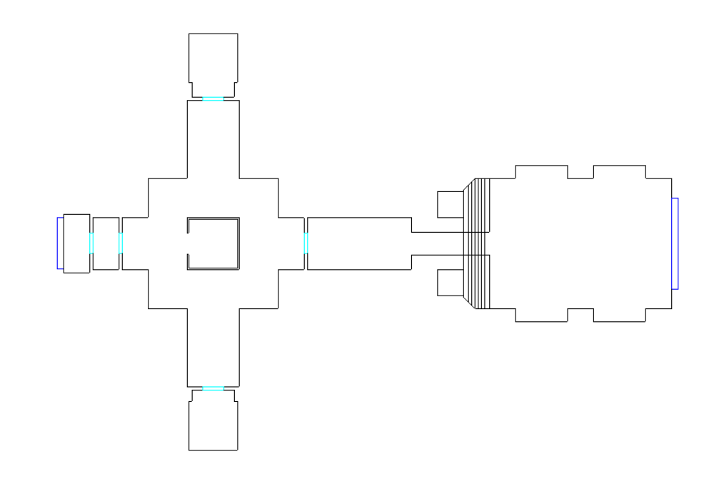
1
2
3
3A
Lift to Level 5
0
3B
Lift to Level 2

Map Level 2

Legend
See rest of document for details
Sectoids:Initial

Guards:Initial

Power pods

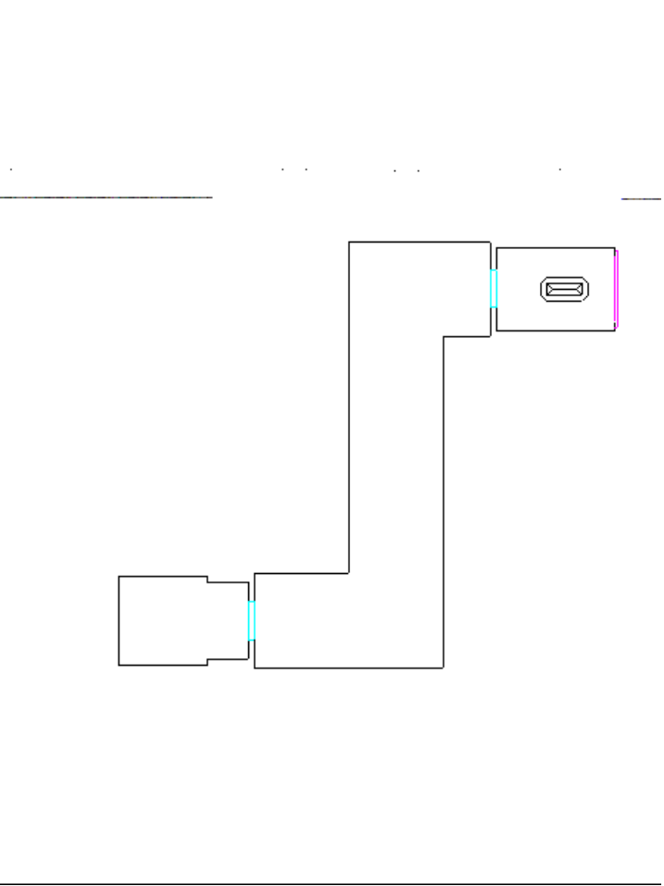
4
5
Lift to Level 1
Additional secret rooms/areas to be developed
4A

Map Level 3

Legend
See rest of document for details
Sectoids:Initial

Guards:Initial

Power pods

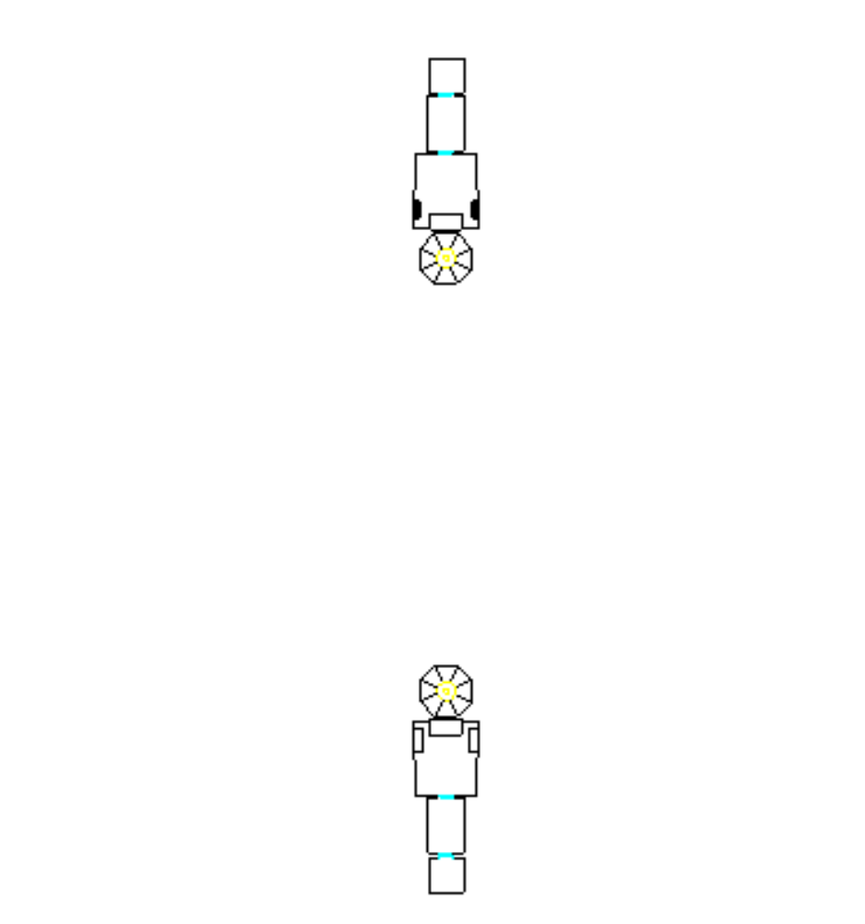
8A
8B
10A
10B
Lift to Level 5
Lift to Level 5

28
28a
28b

Map Level 4

Legend
See rest of document for details
Sectoids:Initial

Guards:Initial

Power pods

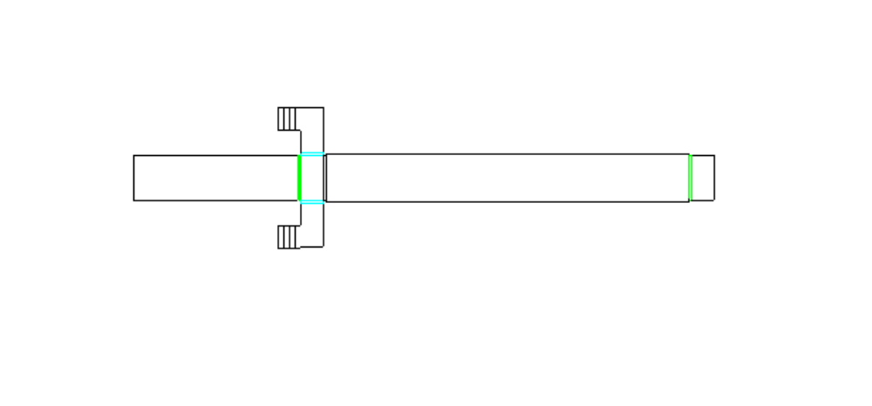
Stairs to Level 5
Stairs to Level 5
14
15

Map Level 5
Legend
See rest of document for details
Sectoids:Initial

Guards:Initial

Power pods

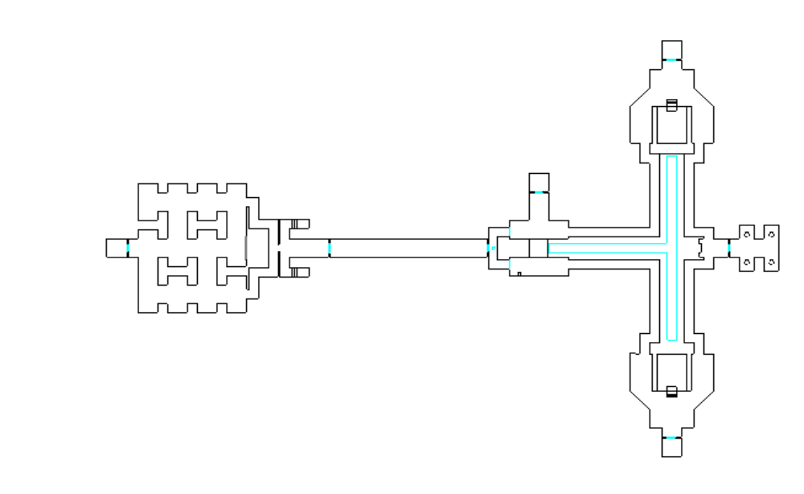
Stairs to Level 4
Stairs to Level 4
Lift to Level 1
Lift to Level 3
Lift to Level 3
Lift to Level 6
Additional secret rooms/areas to be developed
11A
7A
10C
These Two activated by taking Power core in room 8B
13A
6
7
8
9
13
11
122
10

Map Level 6

Legend
See rest of document for details
Sectoids:Initial

Guards:Initial

Power pods

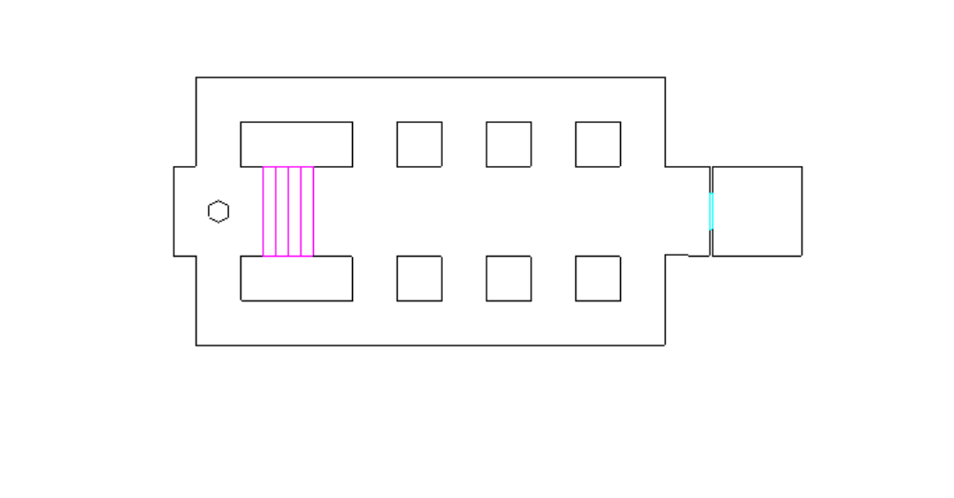
Lift to Level 5
Stairs to Level 7
16

Map Level 7

Legend
See rest of document for details
Sectoids:Initial

High Mentat

Captain

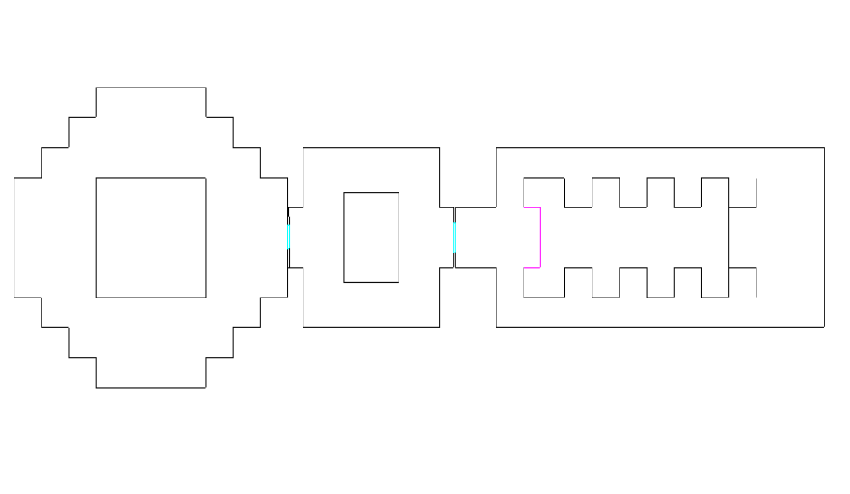
Stairs to Level 7
17
18
19
Additional secret rooms/areas to be developed
18A
19A
19B

Intro to Level

TBD

What has gone before

At the end of Mission 4 the Captain flew to Ascidia to cement the alliance, and still hasn’t returned, but is expected back at any moment.

In mission 4:
The accompanying Ascidian obtained data showing the location of an Elerium mining operation.
Intelligence suggests that this mine is of vital importance to the Sectoids.

Ideally.
- The mission briefing for mission 6 should be given by Yeager, as if this was to be the next mission being undertaken.
- When the ‘run mission’ button is selected instead of going into mission 4 the player should be ‘thrown back’ into the ‘real’ mission briefing below, and given chance to re-assign/equip.
(Could this be done by having a dummy mission, which is automatically completed)
- Pressing the ‘run mission’ button would then run the mission as normal.

If this is too difficult simply use the briefing below.

Player Mission briefing:

Given by Yeager in the Captain’s absence.

“Priority Alert, there is a change to the scheduled mission.

The Ascidian shuttle returning with the captain has been ambushed and destroyed by a Sectoid fleet.

A search of the area has revealed many bodies, but no sign of the Captain.

However, one of the ship’s life pods was unaccounted for, and intelligence suggests that it may have been conveyed to this station on the fringes of Ascidian space. We are therefore assuming that he is still alive.

This base, constructed from hollowed out asteroids, was originally built by the Ascidians, but was captured by the enemy three weeks ago.
Our Allies have provided us with the station schematics, which we have already been downloaded to your suit GIS system, hopefully they should still be accurate.

We have no idea if the Captain is alive or dead, but we know the activities these creatures are capable of, his recovery is of the utmost priority.

Within the station are two power cores. These must be protected at all costs. Once the Sectoids know of our presence they may try to destroy them and with them the station.

Once these cores are reached you may find it useful to leave units on guard, while the remainder of the squad continue on with the main objective.

We can’t get a shuttle near enough without alerting the enemy, and the nature of the site is incompatible with standard breaching pod protocol. Despite this we have no other way of getting you on board, so be prepared for a bumpy ride.

Once aboard you’ll be out of radio contact until you close down the micro-meteor shields. The controls for these are located in the hanger bay control room.

Recommended crew members have already been assigned to the squad.

One last word of caution, the Ascidians use a highly volatile power source stored in pods.

These pods react violently to any high energy impact, so be careful. ”

Structure of level

Overview

A story (plot)
Get the Captain back

B story (subplot)
Get first sketchy hints of the Sectoid master-plan.
Meet the ‘High Mentat’ again (should be first met in mission 3)
Get hold of ‘raw’ Ascidian data records.

Game Aim
Get the captain back
Protect the main power cores from Sectoid attack.

Game function
This will be the first level to have the entire (or almost entire) map available for the player, and introduce the player to harder Sectoids and large amounts of explosives.

Hit locations
The level will also start to have Sectoids which have ‘prepared’ for the player.
They ‘know’ that you have plasma weapons (even if the player hasn’t researched them yet), and will take appropriate action. From Act 2 onwards all the Sectoids here will have silver suits. This will make them virtually impervious to plasma pistol/rifle fire. (Unless a head hit occurs … see Hit location section)

Explosive ‘Pods’
The player will also have to take care because of the amount of explosive items present on this level.

The pods are explosive, and will detonate if fired at by any weapon (but not by knife or similar impact).

Within a certain radius (suggest 64 world units for the time being) the pods will explode other pods and they could thus be used to set off a chain reaction.

Areas with lots of pods arranged in blocks are especially dangerous. Their damage radius is much larger (say 512).

I don’t know how automatically this is implemented in Unreal, but damage ideally should drop off with distance, and explosions should impart vector movement and spin to objects/creatures within the blast radius so they can be blown around the map.

Individual pods should follow a path around the conveyor belt system.
Pods that are destroyed should be periodically ‘replaced’.

Recommended crew members
As the game develops it will become impossible to know which crew members will be alive at any one mission.

To have any form of mission specific dialogue going on at all I suggest that we will need to try and have ‘recommended crew members’.

This will not preclude the player from changing the squad make up. But if he does so then the troopers will have less to say.

Similarly since we don’t know who will still be alive, we should merely say as standard that:
‘Recommended crew members have already been assigned to the squad.’ .

We could use a simple table to tell the program who is recommended for each mission, and those still surviving could be stuck into squad slots.

Alternatively all relevant messages should be recorded in all voices.

For the purposes of this document I will refer the speakers as an ‘ideal’ character.

(Deborah Conway will be recommended for this mission as she has a degree in quantum Physics and may be of use in protecting the Power cores.)

Level B2 Walk through:

Act 1
Setup

Room 0 (Starting Point - Breaching Pod)
- The troopers start out in a breaching pod.
As the level opens the pod should be heading for the station.
Clearly over the radio should come, in addition to the audio from mission 1, the following.

Dialogue:
Patton: Micro-meteor shield in 3 seconds, two, one …. (static, which fades down to nothing over the following few seconds)

After the usual banging and grinding there should be one additional large thump.
No explosion occurs as the pod has entered into the Ascidian landing bay, and is partially embedded in the floor (which is torn up a little revealing the rock substructure)

The Pod door will open, giving access to the hanger deck.
Default should be for all the troopers to go into follow me mode as the player leaves the pod.

Room 1 The Hanger Bay (Level theme Foreshadowed)
- On leaving the pod the player will have 30 seconds before the presence of the Pod is ‘noticed’.(A Sectoid should be scripted to pass by the window of the control room after this time.)

- There are no Sectoids in the Hanger bay, but they will come from either the Control room or the Airlock corridor depending on how the player responds.

- The hanger bay should allow the troopers a brief respite, the choice is the player’s. Either he takes the action to the enemy within a short time period, or the enemy will come to him.

- The area’s ambient sounds are the melodious notes of the Ascidian culture. Although occasionally a more harsh and strident Sectoid like sound should intrude.

- If there are troopers in the hanger bay after 30 seconds have elapsed then the Sectoids in the Room 5 (hanger control room) should be activated, flood out and attack the troopers.

- If the Player approaches the airlock door, the Sectoids in the corridor behind should be activated. Similarly if the player kills the last of the Sectoids from room 5 the Sectoids in this corridor should also be activated (if they haven’t been already).

- The airlock door to Room 2 (The corridor) can easily be opened by the player, however the hanger bay control room doors can only be opened from the control room.

- There should be 2-3 fuel pods scattered about the hanger bay around the edges, a single one should also be present to the right of the airlock door.

Room 2 Airlock corridor to ‘hub’
- Two ‘Normal’ Sectoids which should have been prior activated by the trooper arriving outside the door.

- The doors act as a filter, both should not be open at the same time.

Room 3 ‘Hub’ and Pod lift (The level theme explained)
- The three aliens in here should be activated as soon as either:
- The player enters the middle of room 2
- All the other Sectoids met so far are dead.

These Sectoids should have patrol points scattered all around the room, and should patrol these until they obtain player LOS, or hear the players gunfire.
(This should ensure that the player is never quite sure where they are when entering the room)

- The central part of the room consists of the ‘pod lift’ This should be modified so that it doesn’t look like a player can get in and use it. It should also have a grill covering like in the conveyor belt area on ‘map level 5’. The pods should travel up the tube intermittently.

- Shooting at a pod within the ‘lift’ could be used to bring the conveyor belt on ‘map level 5’ to a halt, and make things easier/more difficult (depending on how you look at it).

- There will be a few (3) scattered pods left carelessly around for the player to ‘use’ if he so wishes.

- This room provides access to 3 other areas:
The airlocks and the lifts to ‘map level 2’ and to ‘map level 5’.

- Room 3A/B(The maintenance area)
- An area filled with machinery (both original Ascidian, and Sectoid). There should be a single lone ‘Mentat’ Sectoid working in here who could attempt to take over one of the troopers and make them fire at the others. The room should be piled high with Ascidian corpses left over from when the station was taken.

Room 4 Corridor to Control room
- The corridor is empty, there should be a room off it (Room 4A) at right angles.

Room 4A Storage room
- This room should contain 2 Sectoids, one armed with a neuraliser, the other with a standard plasma weapon. It should be full of Sectoid apparatus plugged into the back of the wall leading towards the hanger bay control room.

Room 5 Hanger bay Control Room (The level theme explained)
- There are 3 Sectoids in here, all normal and armed with a plasma weapon. Thirty seconds after the game starts they should be activated and one should go to a ‘patrol point’ at the window overlooking the hanger bay. At this point they can be assumed to have ‘noticed’ the intrusion, and will either:
- Attack the troopers, if they are still in the hanger bay, by going through the one way doors into the hanger bay.
- Take up defensive positions near the control panels in readiness for the troopers assault on the control room.

- There are two control panels here, both will react to the close approach of the player by displaying an appropriate symbol or image.

- The first displays a stylised diagram of the station with the ‘micro-meteor’ shield overlaid.
Activating this will shut down the ‘micro-meteor’ shield, and allow the Patton to talk to you again.

Dialogue:
Patton: (Static …)Patton now back on line, congratulations guys.

The effect should be shown by an appropriate SFX (Descending tone, like the sound when Obi Wan shuts down the power for the tractor beam in Star wars). And by a change in the image on the console to one showing the station with no field (colour change as well).

- The second displays a series of symbols one of which is the same as the one on or next to the lift door to ‘map level 5’.
Activating this will ‘unlock’ the door to the lift to ‘map level 5’.An appropriate SFX should be used such as another ‘descending tone’ to indicate that it has been turned off (although much quieter). The console image symbol should also change colour, showing that it has been ‘deactivated’.

Room 3 - Hub - again (Game Point 1)
- Returning through this area again, with the Patton in full communication should result in the following static laced dialogue:
Patton: You should be right next to the main power pod system. Be careful of those things, they interfere with our communications and they explode with little provocation.

Lift to map level 5
- The door to the lift to ‘map level 5’ is locked. Symbols on, or by the door should link to one of the two control panels in ‘Room 5’. The door should be shown as ‘locked’ in some way, perhaps by the presence of a tenuous force field in front of the door.
- The lift will have a single ‘silver suited’ Sectoid in it. This ‘foreshadows’ the fact that from now on all Sectoids will have the ‘metallic suit’.

Act 2
For the rest of the mission all Sectoids met with have some form of ‘armour’. The simplest being the ‘metallic suit’ skin that protects them from plasma fire.

Room 6 Entrance to Pod Conveyor level (level theme shown )
- Leaving the lift the player will find himself in a darkly lit area next to a moving conveyor belt. The Ascidian ‘tones’ are here, but are more insistent and threatening This is a dangerous place.

- The pod conveyor belt is lit in a contrasting red/orange glow, and the machinery ‘hums’ quietly.

- Again this area is initially quiet, giving the player time to decide just what to do, but if he waits too long the enemy will come to him.

- The player can see across the conveyor to ‘room 11’
To the right and left are two archways, both of which have a tenuous force field over them.

- Above the one to the left is a small pyramidal shaped box, it has the symbol on it, used lower down, used to denote a force field.
Each ‘arch’ will have one of these ‘boxes’, but only on one side.
This will be a shootable trigger/object. Firing at it will destroy the object, leaving a damaged ‘hole’, and shut off the force field covering the arch.

Sides of an arch that do not have such a box, can only be opened from the other side. Sectoids will automatically shut down these fields as they approach them.(Once a field has ‘shut down’ it will not reactivate.)

- The player will need to shoot this box to gain access to the corridor ‘room 7’.
- If the player doesn’t do this within 30 seconds The Sectoid just around the corner of the corridor (just out of sight) should be activated and make his way to ‘room 6’. This Sectoid should be armed with a plasma weapon.

Room 7 Corridor to first Power core.
- This corridor initially contains no Sectoids, there are however 2 waiting around the corner, both armed with plasma weapons.
- As the player reaches the end of the corridor the ones around the corner should be activated.(one may already have been dealt with if the player loitered in ‘room 6’)

- On each leg there are also the Sectoids in the corridors on the opposite side of the power pod conveyor belt to consider. These will not notice the player until a weapon has been fired.
- Once alerted these Sectoids will attempt to fire at the troopers from across the conveyor belt.
- Each Sectoid in these corridors will be limited to their own section of corridor to prevent overloading the engine.
- As if this wasn’t enough to contend with the conveyor system will deliver a never ending supply of power pods along the conveyor belt.
These pods explode if hit, and can be used as ‘weapons’ by both sides. Explosions affect every creature in the local vicinity.

Room 7A Secret area - Ascidian goodies
- Just around the corner is a secret area. The trigger should be a small switch, hidden in the dark, only reached by jumping. Inside the room will be an Ascidian Data disk (like a Winged Amulet with terminals attached) on which are stored Ascidian records.

- Just before the archway leading into ‘room 8’ is a bend in the corridor. A single Sectoid armed with a neuralizer is waiting here. He should be activated by proximity. The archway will be inactive.
Dialogue: for when item in LOS, play once only
Patton: That thing looks Ascidian. Whatever it is, we want it, and I want no mention of this find to our allies!

Room 8 Power Core - intact Ascidian
- There will be 3 Sectoids protecting the power core, all will be armed with plasma weapons, and all will be wearing silver suits. They will be arranged on and around the ‘Sphinx head’ so that the player will feel ambushed, and will probably have to pull back.
- The lift will be empty. (The player should be lulled back into not expecting anything in a lift again.)
- Around the corner, is an archway that leads to a corridor to ‘room 9’ This archway will have the ‘force-field box’ on the ‘room 8 side’. Access is only possible if this is destroyed.
- In the corridors on the way to ‘room 9’, are several aliens(see map). They should have been already activated by combat in the corridor on the opposite side of the conveyor belt.
If not or if they have been de-activated since, then they will re-activate either on LOS or after a specific time from the player triggering a trigger just outside the arch (30 seconds). Once triggered they should make their way towards ‘room 8’ and the ‘room 8B’ power core, again to set the ‘overload’ in operation.

Room 8A Power Core - Outer control room - intact Ascidian (PinchpointA)
- There should be 3 Sectoids in here, they have just started working on dismantling an Ascidian console (it should be opened up, tipped over or moved to reveal the wiring below. All should be armed with neuralisers. (see alien types). As the lift door opens 1-2 of them should have their back towards the player going about their business. They should respond either when the troopers leave the lift, or when the first shot is fired. Up until that time they should carry on investigating the equipment. (A series of bending down, and examining it, or of entering data on a ‘hand-held device’ (which can be the neuraliser)

Room 8B Power Core - Inner control room - intact Ascidian
- A single Sectoid in here. Should be activated either with LOS or when the room entered. Either way it should be armed with a plasma weapon.
- After the Sectoids have been initially cleared out, the room becomes a point that must be held. Should another Sectoid get to the console he will be able to initiate an overload of the power core.
- If the overload starts then the player will have two minutes to complete the mission or recover the power core and put it back on line.
- The ‘countdown to the overload is still in Ascidian, and as such should be melodious with frequent ‘wind chime’ or similar effects to mark the passage of time. This countdown should become more ‘verbal during the final few seconds so that the player knows that the ‘end is nigh’.
- Once this power core has been initially taken by the player (aliens in room taken out) the two Sectoids associated with this event (marked on the map) are activated. After a short delay (to give the player time to move out and onwards) They should make their way to this power core and overload it (if they get that far).
- If the power core is counting down to destruction in overload mode then getting a trooper to the panel should deactivate it and put it back ‘online’. This should only be possible if there are no Sectoids present in the room.
- If the power core is again reached by Sectoids then the two minutes’ should start again from scratch.
- These assume the presence in the mission of someone with Engineering, or Quantum Physics. Without one of these skills being present another appropriate message should be given.
- If the core is undergoing overload. Play the following, once.
Dialogue:
Patton: Our sensors indicate that there’s a core overload in operation. Do you copy?

- Alternatively if the player is near (within 1500 units of the core) - again played once
Dialogue:
Patton: Er … We’re picking up some rather excited subatomic particles here which seem to originate in your vicinity. Is there anything you guys can do to calm them down a bit?

Dialogue: less than twenty seconds to core collapse
Patton: It’s going to blow, there’s nothing we can do about it, do you here me, get out of there, get out, now.

Dialogue: Successful re-programming by Specialist
Specialist: Temperature dropping and all readings returning to normal tolerances. It’s safe for now.

Dialogue: Failed re-programming by Specialist - aliens present
Specialist: There’s no way to shut this down, every time I do something they seem to block it with some kind of remote.

Dialogue: Failed re-programming - no appropriate specialist extant
Specialist: I don’t know what the hell I’m doing, the symbols mean nothing to me, we should have brought somebody with the right skills for this.

The following section was missed out of the first draft
- If the countdown continues until zero, the core should explode.
- The explosion should take the following form.
- Easy route
- Screen shakes violently with explosive rumble.
- White out.

- Ideal route
- Lots of screen shaking.
- Fireball mesh (large, bigger than corridor.- this should use Guy’s animated fire texture ) should be spawned at the cores and should follow routes taking them to all parts of the station.
- There need to be enough that they can fill the widest corridor en-route.
- They should be re-used to take out successive parts of the ship.
- the entire destruction should only take seconds, so they need to move at maximum speed.
- They should move very quickly along a route, and destroy any trooper they touch.
- Any troopers window should then show static. In first person view the screen should simply white out.

The player will, if looking
Whichever route is taken the Patton should broadcast this final message.
Patton: The cores breached, its going up….its too late, get out of there… get out of there fast ……

Room 9 Teleport area
- This area is activated by either the player entering ‘room 9’ or by the destruction of all the Sectoids in the corridors between ‘Room 8’ and here.
- The area should continue to spawn groups of 1-3 Sectoids until the power to it is shut off from ‘room 11A’
- Once a Sectoid group is spawned it should ‘decide’ to go to the Power core in either ‘Room 8B’ or ‘Room 10B’. And then head off in that direction.
- Spawning should be random, but if possible with at least 30 seconds between teleports, but never longer than 2 minutes.
- Entering ‘room 9’, or standing by the arch leading to the corridor to ‘room 10’ should activate the Sectoid just around the corner. He will storm out, deactivating the force-field as he does so.
- There will be a couple of Sectoids visible in the corridor on the opposite side of the conveyor belt. Providing the player doesn’t shoot at them they should remain oblivious to the troopers presence. Otherwise they should move into ‘room 10’ and take up defensive positions.

Room 10 Power core - Sectoid altered
- Area devoid of Sectoids. The sound here should be make a lot of the discord between Sectoid and Ascidian technology. The effect of Sectoid ‘tampering’ and alteration should be much more apparent.
- The lift down is untouched, and empty.

Room 10A Power Core - Outer control room - Sectoid altered (Midpoint)
- As the door opens it will reveal an area heavily modified by the Sectoids. Near a Sectoid control panel stands a Single Sectoid, armed with a neuraliser.(see geometry changes)

Room 10B Power core - Inner control room - Sectoid altered
- This room is still Ascidian, just, but all the consoles have Sectoid consoles plugged into them. The ambient sounds in the room should be the discordant mix of Sectoid and Ascidian combined. (Sectoid sounds should be louder).
- There should be 3 Sectoids all armed with plasma in here, they are expecting you.

Room 10C Secret area - Sectoid workings - goodies
- This area is totally invisible to the player, and unopenable, it will open when the Sectoids around ‘room 11’ are triggered.
- The Sectoid inside (armed with a neuraliser) should then attack the troopers from behind.

Room 11 Exit from conveyor belt area
- Again there are no Sectoids visible. Entering this room should cause the Sectoid (plasma armed) just beyond the arch to come through into ‘room 11’. The ‘force field control box’ is on this side of the arch.

Room 11A Secret area - Teleport control room (Pinchpoint B)
- A force-field should be over the door, the ‘power box for this should be hidden in the shadows near the high ceiling. The box should still be in a vertical line from the door, but in the dark, and with a much greater offset, it will be harder to find. The player will kick himself for not finding it.
- A single control, again Sectoid, will show the teleport pad as operative on a display. This condition can be toggled on and off. If the player inadvertently toggles it twice, tough.
- The room should contain a single ‘Guard’(activated on LOS) left behind to protect the controls. The guard is probably too big to get down the corridors, so it will be restricted to ‘Room 11’ and ‘room 11A’.
It should therefore relatively easy to kill (its stats should be a little reduced as well). These factors should make the player a little overconfident when he meets the ones in ‘room 13’.

Just around the corner are another two Sectoids, they should activate either on LOS, or when the ‘Guard’ is activated. One should be armed with a neuraliser, the other with a plasma weapon.

Room 12 Upper Asteroid access tube
- The doors to this tube are locked from the inside. The Sectoids intend to hold this area, and will not allow entry. There should be 4 Sectoids here, one of which is a commander, all should be well equipped with plasma weapons.
These Sectoids will stay here until the player clears out the Sectoids on the stairs to map level 4. They should then open the door and attack the player en mass.
The commander should drop a pass card allowing access to ‘room 13’ on his demise. (I would suggest that we use pass cards like keys in quake or unreal)
We could allow a maximum of say 5 per map, allocated as ‘security levels’, and not carry them over from mission to front end/inventory. This would make using them in game easier. We don’t then have to worry about textures, or meshes etc. All 5 cards could become part of the system, for use to use as and when required.
- Just by the door, on the players side, is a floor hatch, it should be shootable out. Once the hatch is open the player will see a force-field blocking the way down.
- Directly above the hatch in the ceiling, and hidden in the shadows, should be the box that controls this force field. Shooting it should shut down the field.

Room 14 Lower Asteroid access tube (Game point 2)
- Once in the lower access tube, the player will find his route clear, apart from scattered fuel pods. (These haven’t been marked on the map yet, and will need to placed in game).
- Once the player gets to a point somewhere in the middle of the corridor, the internal security system will kick in and start the ‘vaporizer’.
- The ‘vaporizer’ is ‘force-field’ which travels the entire length of the corridor, and which ‘vaporises’ anything in its path.
- Any pod that comes into contact with the ‘force-field’ will explode, if that in turn is close enough to another pod, then a chain reaction will occur. (Shades of the old Doom ‘barrels of fun’ level).
- The troopers must keep on moving. They will have a limited time to get to the end and open up the maintenance hatches to access the stairs back up to ‘map level 5’.
- The maintenance hatches should be ‘shootable out’.
- Once through either of these hatches, the player will meet two Sectoids, both armed with neuralisers. They should be at the top of either staircase, and should be activated to go to whichever hatch is opened.

Room 15 Access tube maintenance rooms
- The force field over the door is controlled by a box hidden in the ceiling shadows, although the player should be getting used to this by now.
- This is an area filled with Ascidian technology, and not yet tainted by Sectoid interference. It should have some goodies present. It is a bonus room and contains no traps or enemy (although it would be a very bad place to be trapped in with a Guard).
- A lift can take the player back to ‘room 13’
- A switch at the end will turn off the force-field to ‘room 14’.

Room 13 Power pod storage area
- The room should be closed off by two force-fields (which should look different to the others on the level) or by two doors labelled with a Sectoid emblem until the player obtains the key-card dropped by the Commander.
The key-card should operate as a proximity device. If the player is within 512 units of the field it should deactivate automatically, reactivating again when he passes beyond that range.
- As the player enters this room it should be apparent that it is a very dangerous place to be.
The lighting, and ambient sounds are still very much Ascidian, with only a slight overlay Sectoid tones. The room is lit similarly to the ‘power pod conveyor’ and it soon becomes apparent that there are hundreds of these buggers stored in the alcoves.
- There should be three ‘Guards’ in here. Two should be ‘Females’ the sex that has been met with before. The other should be the male, and very tough (see ‘Alien Types’ section).
- Any hit to one of the individual pods, or the racks in the alcove should cause an explosion. (see Pods and Explosions in the ‘Game Function’ section earlier).
- The pod ‘racks’ will be put in either as movers or objects, either way hitting one with a shot will cause it to explode with devastating force. A pod rack explosion should be many times bigger and more destructive than an ordinary single pod.
The explosions will not cause adjacent racks to explode as they are shielded by the alcoves in which they lie (This was a safety design). They will however cause the back wall of the alcove to be destroyed. A second ‘explosive’ hit to the weakened wall should be able to cause a rack on the opposite side to explode. The result will be a forced opening in the wall.
If one of the racks in particular explodes it will provide access to a secret area, camouflaged by the Ascidians, where ‘pod testing’ is carried out.

Room 13A Power pod test room
- The room is used to test the power of the pods as a QA stage. It should contain wonderful moving Ascidian technology, and readouts of pods moving through the system. The pods are protected behind blast doors.
- This room contains two Sectoids, both armed with neuralisers. There will be Sectoid goodies stored in here.
- A short passageway leads down to the hidden entrance.
- The Sectoids in this room should make their way to ‘map level 6’ once the player has set foot there.

Lift to map level 6
- The lift can be called with the button at the base, alternatively if all the Guards are dead, and 30 seconds have passed it should descend and its occupants be activated.
- The lift will have three ‘silver suited’ Sectoids in it.
- Two will be Mentats, each will attempt to take over a different trooper, and cause them to attack his comrades, or the player. If a controlled trooper dies then the Mentat should choose another target.
- The other should be a commander, and should specifically target the player if in LOS, otherwise any other trooper will do as a target.

Act 3
Room 16 Alcove room - lower section (Crisis)
- This room is a double threat, not only has the player to avoid and dispatch the ‘Guards’ on this floor, but the upper section (Room 17) has sniping Sectoids.
- The teleport hidden behind the stairs will remain active and either A Guard, or a Sectoid should teleport in randomly every 30 seconds - 2 minutes, until the power is switched off via the controls in ‘Room 18’. This should obviously be disabled if there are likely to be too many (number to be determined) creatures active at any one time.
- The Door to the lift should close after about 15 seconds, and the lift descend automatically.

Room 17 Alcove room - upper section
- Three Sectoids sniping down on the player.
- One should be directly over the entrance to ‘room 16’ below, so that he has a clear shot at the troopers should they enter the open part of the room.
- A door next to the stairs leads to ‘Room 18’
- If the ‘room 16 teleport’ has been disabled, the area just outside this door leading should open the camouflaged door to ‘Room 18A’, and activate its contents.
- Any attempt to climb the stairs should result in the Sectoids moving to defensive positions near the door, to hinder the player.
- Sectoid routing should try and make them hug he back wall when moving if at all possible, and only come to the front when selecting a target.

Room 18 Teleport control and guard area
- The doors to this room should open slowly, from the floor upwards
- A single armed Sectoid is present in this section, He should be armed with something a bit more meaty than a plasma weapon, suggest grenades, which he can throw out of the door as it opens. He should stand his ground, defending the console.
- The Teleport controls for the unit in ‘Room 16’ are here and should be easily turned off. As with the previous console the state of the teleport should be obvious by the image on the panel, the switch should act as a toggle so that it could be mistakenly re-activated.
- The hidden area ‘Room 18A’ is on the opposite side to the above controls.
- The door to ‘Room 19’ is locked, with no visible means of unlocking it.

Room 18A Hidden Sectoid sleeping chamber room
- This room should be well hidden, but something should be present to hint to the player that there is something here.
- The hidden door to the room will be activated when the player, having disabled the teleport’ goes back into ‘Room 17’ thinking he’s missed something.
- There should be two Sectoids in here, they should head out for the teleport console and ‘reactivate it’ if they get close enough (this should surprise the player a bit).
- They should then take up defensive positions near the door to ‘Room 17’ and wait for the player to return.
- There should be a control panel which unlocks the door to ‘Room 19’ Again with appropriate symbols active on it.
- This room should be converted from an Ascidian room, but little should remain from Ascidian occupancy, except a few torn out blocks.

Room 19 Base control room
- The Room should be basically Ascidian, but there should be small Sectoid consoles attached alongside the Asdidian console, which should have plates and sections removed. The area around the door way to ‘Room 19A’ should also have heavy Sectoid influence.
- On entry to the room the player will see 4 Sectoids. Two normal, one Commander and one we will refer to as ‘The high Mentat’ this Sectoid will have been met already. (see ‘Alien types’ section).
- The two normal ones, armed with a plasma weapon will attack the player.
- The Commander should head for Room 19A, the automatic door closing after him.
- The ‘High Mentat’ should head to room 19B, stopping just inside the door to watch the action.
- The Ascidian console should be inactive, with no circular displays over it.

Room 19A Interrogation room (Resolution)
- This room should be decidedly Sectoid in appearance. It should be dark and dominated by the large circular, or Octagonal, ‘interrogation table’. The Sectoids certainly have used this room a lot!
- This table should have the ‘Captain’ spread-eagled across it. His face and head should be visible, but he should be capable of only moving his head from side to side, or small movements of the hands or feet. The texture ‘skin’ should show lots of wounds, and areas of clothing ripped away to provide access for fiendish equipment.
- In particular a large ‘device’ should be aimed at an exposed midriff area, this device could even intersect the ‘Captain’ mesh , with suitable blood stains around the area of ‘penetration’.
- On entry to the room the Sectoid will start firing at the ‘Captain’, it should take a good few shots to kill the Captain (but it should be possible if the player is stupid and does nothing).
- If the player, or any trooper shoots at the Sectoid and hits then the Sectoid will adopt them as a new target. Ideally this Sectoid should target the player if at all possible.
- Once the room contains no threat a message from the Patton should kick in.

Dialogue: If the Captain is alive
Patton: We’re picking up life signs, he’s still alive. Congratulations team.

Dialogue: If the Captain is dead
Patton: Were picking up no life signs, we’re too late. He’s gone!
Then additional messages depending on what is still happening. (They should be said in this order as things are resolved.)

Dialogue: If a countdown is in operation:
Patton: You’ve still got things to worry about guys, The sensors report a build up in radiation, those reactors are going to blow in seconds.

Then a few seconds later:
Dialogue: If the console in ‘Room 19’ hasn’t been activated
Patton: Our allies suggest that if you close down the stations automatic defences they can come in and help you clear up. The defences should be controlled from a couple of consoles somewhere in your vicinity.

- There should also be Sectoid console which indicates, via the display, that power has been diverted from the Ascidian controls outside in ‘Room 19’ to the ‘Interrogation device’.
Triggering this console should result in a graphic change and activate the Ascidian controls in ‘Room 19’. This should result in appropriate sounds of Sectoid noises winding down and Ascidian noises ramping up, and the following audio.

Dialogue: If the ‘Captain’ is alive
Captain: Thank you … I owe you!
(Said with great shakiness and fatigue)

Room 19B Escape pod
- The room is Ascidian, The escape pod should be Sectoid in design and Texture.
- Once the ‘High Mentat’ gets into position it should attempt to control one of the troopers into attacking a different trooper, or the player.
- If the ‘High Mentat’ is shot at, it cannot be killed (but the player doesn’t know that). It can however take damage, and animate accordingly.
- If the ‘High Mentat’ takes damage, or if it is approached within 512 units by a trooper, then it will break off its mental attack, and a force field will be activated in the door frame. This will effectively cut it off from the players reach, and allow it to watch goes on.
- The ‘High Mentat’ should appear to watch the actions of the player carefully, and periodically make small movements to a device (neuraliser) in its hand, as if its entering data into it.
- If the Player tries to attack the Mentat through the force field, it would be ‘nice’(but probably too difficult/time consuming to implement) if:
The Sectoid recoiled the first time (but only the first time), and every successive time it merely laughed maniacally and entered yet more data into its ‘neuraliser’.
- If one of the following conditions happens:
- The Player approaches the ‘force field’ closely to look at the Mentat.
- The Player activates the consoles in ‘Room 19’
- The countdown to self destruct gets to 15 seconds
Then the ‘High Mentat’ should ‘gesture’ (point or preferably make a more ‘suggestive’ gesture) towards the Player’s trooper. This action should be accompanied by verbal Sectoid noises (Suggest something that sounds like hysteria or manic laughter.). This should be reasonably loud to ‘remind’ the player that this guy is still present.
The ‘High Mentat’ should then enter the escape capsule and the capsule should be ejected.)

NB:
The player can never get into this room, it exists solely so that the ‘High Mentat’ can escape in a dramatic manner.

Room 19 Base control room The ‘Finale’
- The player now returns to ‘Room 19’ to find that the Ascidian console is now active.
- If the player manually triggers the console then he gets the end sequence of the top of the station opening up, and the fly by of Ascidian ships, as he does so he gets the following message:
Patton: Sensors reveal that the stations defences have now gone off line, and our Allies say they’ll be with you shortly.

If a countdown is still in operation he then gets the following message:
Patton: The Ascidians report that now you’ve opened up the system they have managed to abort the overload remotely. Our readings indicate rthat the cores are cooling down and the danger s past. The station is now secure. Well done guys, come on home, we can leave the mopping up to them.

If possible it would be extremely nice to have the Captain limp in from ‘Room 19B’ and say his ‘line’ at this point. This is really wish stuff and would be a lot of work. It should be put on the wish list stuff for the future if there’s time.

Debriefing

Successful:
(Read by Yeager)
The Captain has been successfully recovered, and sends his good wishes to all, he is however in no fit state to resume command.

In the meantime you take your orders from me.
The Ascidians were exceedingly pleased to get their base back intact. Judging by their reactions our operation has either impressed the hell out of them, or scared them rigid. Its impossible to tell which.

The outcome certainly seems to have given us some decent Brownie points, they ‘made a gift’ of several tons of fresh supplies, although stores have no idea what bits are edible, so expect some unusual meals over the next few days.

Here’s a list of what we recovered, and the usual mission breakdown. You did good.
Normal Debriefing text.

Failure:
(Read by Yeager)
With the Captain not recovered the Patton’s morale dropped to an all time low.
The loss of his experience and knowledge was a blow from which we never recovered, and without his leadership, we were unable to prevent the Ascidians from being defeated.
(Cut to End game failure sequence)

END OF MISSION

Additions / Changes in more detail

Equipment for level

Changes to Geometry/layout

Most proposed changes occur in the earlier part of the mission.
Check the relevant room description for more detail
- Room 1:
- Needs to be shorted, remove about half of map
- Better Texture for Ascidian floor needed.
- Breaching pod needs to be added to map. This should also have an external shell. Because of difficulties with unreal this may be better handled as a warp zone, with the interior part somewhere else entirely. Pod should ideally lie at a slight angle in all planes.
- Damaged floor sections around breaching pod
- Items to act as cover for troopers. Consoles, or stanchions or ‘pipes’ or other ‘apparatus’.
- Doorway to Room 2 needs an Airlock Door. This should be different from the others in texture.

- One way doors added linking the Room 1 (Hanger) to Room 5 (Control room). These doors should only be operable from Room 5.

- Room 3
- The ‘Pod lift’ should be changed so that it doesn’t seem so inviting for troopers.
- Reduce cross section to a round tube just big enough to take a ‘pod’
- Reduce view into the ‘lift’ by making the player look through a grill (similar to those on Map Level 5) to see the pods.
- There does not need to be a direct connection with level 5. The player will just see an stream of these pods going upwards.
- ‘Room 3A + 3B (The airlock) - Sorry for the numbering here, but I forgot about them.
- This needs to be made more of or dropped entirely
- Easiest suggestion would be to make it larger, and filled with machinery (both original Ascidian, and Sectoid). There could be a single lone ‘Mentat’ Sectoid working in here who could attempt to take over one of the troopers and make them fire at the others. This room could be cobbled together using existing rooms/geometry and brushes. Ascidian corpses go here.

- Room 4 (Corridor to Hanger bay control room)
- Add an extra room off this.

- Room 4A Storage room
- The room is little more than a storage room, and should contain some alcoves with sliding hatches. There should also be some Sectoid alterations in here, rewiring and adapting the Ascidian technology (rip off one entire wall).

- Room 5 (Control room):
- Enlarged, effectively split into two areas with a ‘support strut’. The front half is empty and is a viewing are, where the hanger can be overlooked. There are also the two doors which give access to the hanger here. They are proximity doors that open from this side only and then close after 20 seconds or so. The rear half dives access to the corridor leading to the lift.
- Existing console moved and paired with another to act as a ‘portal between the two halves.
- The lighting changed to a colour that contrasts well with the hanger bay lighting, to give a better silhouette view of any creatures in the room from the hanger.

- Room 6 (Top of lift, entrance to conveyor belt level)
- Area just inside the conveyor belt should be changed to show only an opening big enough for the power pods to come up.
- Add a mover that does the ‘lifting’
- Change lighting inside the conveyor to orange/red to make it more threatening.
- Change lighting in ‘room 6’ to make it less well lit in the ceiling, and more lit by the light from the power pod conveyor belt.

- Room 7A
- Add this room, small Ascidian, not found by Sectoids.
- Add door trigger, which should be a small switch, hidden in the dark, only reached by jumping. Inside the room will be an Ascidian Data disk (like a Winged Amulet with terminals attached) on which are stored Ascidian records. This should be placed in a small recess at the back which has a cover triggered by proximity.

- Room 8
- Make more dramatic, change lighting to make the power core cap light the area with a reddish tinge.
- Room 8A
- Make larger, not so linear, add console on side being ‘adapted’ by Sectoids
- Room 8B
- Re-visit lighting
- Room 9
- Change to have only 3 Sectoid beaming points, arranged as on map. Change room geometry accordingly.

- Room 10
- The effects of Sectoid changes should be more apparent. Add more removed panels, torn up floors and free standing Sectoid consoles.
- Room 10A
- Same alterations as for ‘Room 8A’, the room should also be far more Sectoid in character, Comments similar to ‘Room 10’
- Room 10B
- Same alterations as for ‘Room 8B’, the room should also be much more Sectoid in character, comments similar as to ‘Room 10’.
- Room 10C
- New secret area. Behind the Ascidian door this room should be almost pure Sectoid. They’re doing something weird in here.

- Room 11
- Same changes as for ‘Room 6’. ‘Power box’ should be hidden in ceiling shadows.
- Room 11A
- New area, needs to be large enough to take a guard, same for door ‘room 11’
- Add teleport controls, with toggleable state between on and off
- Room 12
- Add shootable hatch, force field, and its controlling box.
- Room 13
- Create ‘mover’ for ‘pod rack’ texture to be done by art. Position at all relevent place on the map.
- ‘Pre-damage’ wall sections behind racks.
- Room 13A
- Create room, and Pod test machinery/animation
- Room 14
- set up Vaporizer for scripting.
- Add shootable hatches at the end.
- Room 15
- Add force field controller box
- Add ‘hidden area’ containing nooks for goodies.
- Add switch to turn off forcefield to ‘room 14’.
- Room 18
- Add teleport control, and associated toggleable display
- Room 18A
- Add this room with sectoid sleepingchambers
- Add Room 19 door switch
- Room 19
- make console displays switchable.
- put together end sequence animation.(better Ascidian fighter animation)
- Room 19A
- Create this room as a Sectoid torture chamber with large experimental table.
- Add torture machinery.
- Add power switcher geomeetry and power switch itself
- Room 19B
- Create the room as a ‘shell’ for the Sectoid escape pod

- General to this map level.
- Create sky box
- improve asteroid texture
- Add ‘force-field boxes’ above relevant side s of the archways)
- Add force-fields to arches switchable by close approach by aliens or by shooting the associated ‘box’.
- Alcoves also to added at appropriate points for placement of objects at ‘trooper height’.
- Alter door shapes to get rid of the ‘ankh’ bit.
- Change doors to work on proximity rather than manual opening unless the door is large and specific.

Difficulty level.

Alien Types
The following Sectoid types from mission 1 are also required here.

Sectoid types from mission 1

- Sectoid, unarmed.
These should always run away. Ideally they should head for a nearest alcove (to be added in geometry), open it, and take out a plasma pistol. Each Sectoid could have its own allocated alcove for this purpose.
- Sectoid unarmed, but working at a console, even if the player attacks (He’s trying to garble the system and prevent data being taken, or warn the fleet). I’m unsure if animations exist for this.
- Sectoid, armed with Plasma pistol.
These will automatically attack, and behave as the AI currently controls them. They should not attempt to close in to the player.
- Sectoid armed with ‘neuraliser’
A neutraliser is effectively the little gadget used by the aliens in ‘The invaders’. It is a small circular (octagonal) disk held in the Sectoid’s hands that can incapacitate, and kill.
A Sectoid with one of these will attempt to get close to a trooper. If he does and can use the weapon in close proximity. (Animation of the Sectoid raising it to towards the trooper and a red flash. Accompany a successful attack.)
If successful The trooper falls to the ground, stunned. But will recover in, say, 15 seconds. Unless a second attack is made in which case the trooper is dead.
The device will need 5 seconds to recharge.
These Sectoids are obviously easy to shoot, but woe betide the player that lets them get too close. If the player is ‘stunned’ in this way, but not killed, he will be able to watch what is happening around him, but not issue orders until the paralysis wears off. Health should be reduced by about 20 points per hit.

Alternative Sectoid textures
- Sectoid wearing a silver suit. Sectoids wearing this will be immune to plasma fire unless taking a hit to the head.
- Sectoids with different head tattoos denoting rank or specialism.
Suggest:
- Grand commander (purple and complex rank should have some repeating motif, like bars, to suggest degree of rank)
- Commander (purple denoting rank, but relatively simple)
- Scientist
- Pilot
- warrior (something very simple)
- Drone (nothing)
- Mentat (the ones that can use Psionics) they should have a pineal swelling on the head, roughly where the pineal eye is.
- Sectoid wearing armour of some kind, body hits immune to most things, but kinetic energy weapons should knock them over.

New Sectoid skin

A specific Sectoid Mentat ‘skin’ is also required. This skin has been dubbed the ‘High Mentat’.

High Mentat
This ‘skin’ should have unique differences that tell the player that this particular individual has been met before, and will be met again (because he gets away in this mission too).
Suggested differences are:
- Colour of eyes
- Scar(s)
- Disfigurement (perhaps missing an eye)
- Distinctive costume or logo.
The ‘gross’ differences are so that the player can recognise him at a distance, the ‘character specific ones’ so that he ‘knows’ that this is the same one.

Although the player will be frustrated at the aliens departure, his eventually satisfaction at taking out this particular alien will be much greater when the opportunity final arrives.

Alternative Guard skins

This will be the second time the player will experience ‘Guards’.
It would be nice to ring the changes ever so slightly and introduce the ‘other sex’.
I suggest that the player has only come across females before, but this time there is also males present.

Males should be far darker, (almost melanistic, perhaps with a reddish streak down the back and a slightly paler underside. The head should also be more orange/red than the rest of the animal.
(Almost Rotweiler like).

The male should be:
- Tougher
- Faster (if possible)
- More dangerous

Extra objects

Gore

A pile of Ascidian corpses.
This should be an object, perhaps cobbled together from several Ascidian meshes, to avoid redoing mapping.
The object does not need to animate,
(Similar piles of dead Ascidians will be useful on other levels, so its well worth while doing it.)

We can use single dead ascidians already, so the following denominations of piles are needed.

- 3-5 Ascidian corpses
- 8-12 corpses.

The meshes should be as simple as possible and the texture should do most of the work.
Firing at the pile (should people be sick enough) should merely blow ‘gib’ blocks off it and leave blood stains.

This will allow us to get really sick.

Alternative textures with the piles as more like skeletons would also be useful for later missions.

Captain Mesh/Texture
This should be based on a trooper suit, and be well bloodied with bits torn off..
The helmet should be re-modelled to approximate a head, onto which the Captain’s features can be textured. It’s important he is distinctive and recognisable.

Extra animations for being spread-eagled on the interrogation table will be needed.

Power Pod
This should be a simple ‘Pepper pot shape, Hexagonal, and tapered from the base to the top. Again the texture should be made to do most of the work.(If this explodes there should not be any debris)

Power Pod rack
This is the rack into which the Power pods fit, they should probably best be done as movers, but since they also need to explode violently several sections need to be done to bounce around in the explosion, along with the texture needed for both.

Recommended Programming Additions

Hit locations should be implemented. This has been discussed, and agreed in principle, but nothing has yet been done.
This can be quite crudely done, but should allow for the following locations/ effects:

Area | Effect
Head | Double damage
Torso | Normal
Legs | Reduce mobility -at least for enemy creatures (possibly)

And At least for the following facings.
- Front
- Left side
- Right side
- Back

A fairly simple implementation has been agreed with Fin.

This involves 3 vertical bands, and either Front or rear facing.

Hit locations are either: Head (top section), Body (Middle section), Legs (Lower section)

Head hits do double damage, Leg hits reduce mobility.

Level B2 Requirements broken down by Department

Level B2 Art requirements
Requirement | Description | Size/Bitdepth |  |  | Priority
Switch graphic | texture for general open and closed door switch | 64*64 or 64*128
 | 3D object for ascidian switch. | 16 polys tops
In game object | Fuel pod | 6,or 8 sided pepper pots, simple shape. 48 unreal units high, slightly tapered. |  |  | 1
 | Texture for fuel pod | 64*64 or 128*128 |  |  | 1
 | Texture for pod rack | 128*128 0r possibly 128*256 |  |  | 1
 | Texture for damage rock wall section behind pods | 128*128 0r possibly 128*256
 | Explosions for above (could use existing ones) | As current
Door texture | Re-do existing Ascidian door texture to sharpen it up a little, and get rid of the ankh graphic (its too blurred) | As current
 | Asteroid macro texture for outside view | 128*128 and 256*256 (just in case)
Room 0 | Breeching pod mesh | As for mission 1 briefing |  |  | 1
 | Breeching pod texture | 256*256 (all textures needed on same page) |  |  | 1
Room 1 | Ascidian airlock door texture, meaty with some design on it. | 256*128 or possibly 256 *256 |  |  | 2
 | Ascidian floor logo texture | 256*256
Room 3 (among others) | Ascidian/Sectoid blend material textures | 3* 128*128
Room 3A/B | Small Ascidian corpse mesh | 150 polys tops
 | Small Ascidian corpse texture | 128*128
 | Large Ascidian corpse mesh | 250 polys tops
 | Large Ascidian corpse texture | 256*256
Room 5 | Ascidian Control panel 1:Micro meteor shield ‘on’, | 128*128
 | Ascidian Control panel 1:Micro meteor shield ‘off’ | 128*128
 | Ascidian Control panel 2:Force field symbol on | 64*64
 | Ascidian Control panel 2:Force field symbol off | 64*64
Room 6 | Silver suited Sectoid texture | As for Sectoid texture
 | Triangular ‘Power box’ mesh | 24 polys tops
 | Power box texture | 64*64 or possibly 128*128
Room 7a | Winged ascidian data disk (amulet-like) | 30 polys max
 | Texture for above | 128*64
Room 8 | Sphinx ‘head’ asc file for import into editor | 30 polys max
 | Head texture, look at existing one and stylize | 128*128
Room 8b | Ascidian Console - Power overload texture - overloading (center section) | 64*64
 | Ascidian Console - Power overload texture - safe(center section) | 64*64
Room 11a | Sectoid teleport console - showing teleport active | use paul’s current console size
 | Sectoid teleport console - showing teleport inactive | use paul’s current console size should be a distinctive difference in colour.
Room 12 | Alternative ‘glass texture’, not dirty. | 128*128 max, pref 64864 or similar
 | Shootable grill texture | 128*128 max pref 64*64
Room 13 | Male ‘Guard’ texture | AS for female guard. Should be darker, with a reddish head, Rottweiller like.
Room 18A | Sectoid console panel with locked door symbols | 128*128 max
 | Sectoid console panel with unlocked door symbols | 128*128 max
Room 19A | Sectoid console power going toSectoid torture machine | 64*64
 | Sectoid console power going to Ascidian com consoles | 64*64
 | Sectoid torture device texture | 128*128
Room 19 | Texture for Ascidian fighter | 128*128

Level B2 Sound Requirements
Requirement | Description |  | Notes | priority
Mission briefing (06) | Fake (read by Yeager, but same as if captain reads it ijn the real mission 6) |  | Don’t do at the moment
Mission briefing (05) | Change of plan stuff see appropriate section
Dialogue/mesages
Pattonsheildcountdown | Patton:  Micro-meteor shield in 3 seconds, two, one …. |  | (static, which fades down to nothing over the following few seconds)
Pattonbackonline | Patton:  Patton now back on line, congratulations guys. |  | (static, which fades into the message over a half second or so)
Pattonpodinterference | Patton:  You should be right next to the main power pod system. Be careful of those things, they interfere with our communications and they explode with little provocation.
Pattonfindfirstamulet | Patton: (Yeager or Captain)  That thing looks Ascidian. Whatever it is, we want it, and I want no mention of this find to our allies!
Pattondetectoverload1 | Patton:  Our sensors indicate that there’s a core overload in operation. Do you copy?
Pattondetectoverload2 | Patton:  Er … We’re picking up some rather excited subatomic particles here which seem to originate in your vicinity. Is there anything you guys can do to calm them down a bit?
Pattoncorecollapsingsoon | Patton:  It’s going to blow, theres nothing we can do about it, do you here me, get out of there, get out, now.
Pattoncaptainlives | Patton:  We’re picking up life signs, he’s still alive. Congratulations team.
Pattoncaptaindead | Patton:  Were picking up no life signs, we’re too late. He’s gone!
Pattoncaptaincore1 | Patton:  You’ve still got things to worry about guys, The sensors report a build up in radiation, those reactors are going to blow in seconds.
Pattoncaptaincore2 | Patton:  Our allies suggest that if you close down the stations automatic defences they can come in and help you clear up. The defences should be controlled from a couple of consoles somewhere in your vicinity.
Pattonendmission05A | Patton:  Sensors reveal that the stations defences have now gone off line, and our Allies say they’ll be with you shortly.
Pattonendmission05B | Patton:  The Ascidians report that now you’ve opened up the system they have managed to abort the overload remotely. Our readings indicate rthat the cores are cooling down and the danger s past. The station is now secure. Well done guys, come on home, we can leave the mopping up to them.
Captainrecovery | Captain:  Thank you … I owe you!
General specialist dialogue | (all relevant specialists should record this dialogue)
Specialistsavecore | Specialist:  Temperature dropping and all readings returning to normal tolerances. It’s safe for now.
Specialistbockcore | Specialist:  There’s no way to shut this down, every time I do something they seem to block it with some kind of remote.
Specialistfailcore | Specialist:  I don’t know what the hell I’m doing, the symbols mean nothing to me, we should have brought somebody with the right skills for this.
General
SFX | Ascidian Countdown to destruction as the core overloads Overload starts  (or as MOD file) |  | Verbal, announcing the start of the countdown
SFX | Gentle reminders every 30 seconds, |  | Reminders should be verbal.  Countdown tones should be melodious with frequent ‘wind chime’ or similar effects to mark the passage of time.
 | Final countdown |  | This countdown should become more ‘verbal during the final few seconds so that the player knows that the ‘end is nigh’.
 | Ascidian Countdown to destruction is canceled |  | Verbal, announcing the cancellation of the overload, followed by a distinctive chime.
SFX | Sound of breaking power box |  | like a insectocutor,
SFX | Clatter of bouncing bits of box (above) |  | is this automatic?
SFX | Sound of breaking access grill
SFX | Sound of bits of access grill hitting the floor.
SFX | Sound of Ascidian lift speeding up
SFX | Sound of Ascidian lift slowing down
SFX | Sound of Ascidian lift moving constantly
Room 1
SFX | Hitting the hanger bay floor noise, usual breaching pod noises. |  | Extra large thump, and grinding noise, v short.
Room 2
SFX | Heavy sound for Ascidian airlock door
Room 3
SFX | Regular ‘beat’ of Ascidian pod lift in operation. |  | Almost ‘tunefull’
Room 5
SFX | Micro-meteor shield shutdown |  | (Descending tone, like the sound when Obi Wan shuts down the power for the tractor beam in Star wars).
SFX | Door field shutdown |  | Different and quieter descending tone.
Room 6
SFX | Background tones Ascidian, but threatning
Room 9 + 16
SFX | Background Sectoid Teleport ambient (if not already done)
 | Teleport in sound (Rising tone)
 | Teleport out sound (Falling tone)
Room 11A + 18 | Teleport controls, should be distinctive sounds for turning a Sectoid console on and off. |  | These sounds should be re-used
Room 13A | Sound of test equipment, |  | A series of little bleepy tests ad something much more meaty.
Room 14
SFX | Sound of ‘vaporizer’ - normal hum |  | Giant version of an insectorcutor crosses with a tesla coil.
SFX | Sound of ‘vaporizer’ - ZAP when something touches it |  | Very loud and electrical
Room 18A | Sectoid ‘sleeping chamber’ sounds |  | (use something from mission 1)
Room 19A | whirlly Sectoid nasty machine. Very horribel. |  | Aspects of dentists drill, and medical heart/lung machines in background
Room 19B
SFX | Launch of Sectoid escape pod

NB. See also Environmental analysis for Level A1 for additional entries (Console, Teleport etc.)

Level B2 Environmental Analysis
Object | Title | Detail |  |  | Range visible
General
Breeching pod | As for mission 1
Power pod | Environmental analysis | Localised Elerium specific radiation. Radiation level low. |  |  | 64
Power rack | Environmental analysis | Elerium specific radiation. Radiation approaching suit tolerance limits |  |  | LOS
Ascidian corpse(s) | Bio Analysis | Deceased organic biological entity: Form matches type known as Ascidian with a 96% probability. |  |  | 64
Sectoid corpse | as for mission1
Sectoid  Gibbed bits | as for mission1
Un-researched /unused weapon  (All types) | as for mission1
Un-researched /unused item  (All types) | as for mission1
Plasma pistol | as for mission1
Plasma rifle | as for mission1
Neuraliser | as for mission1
Un-researched lifeform  (All types) | as for mission1
Sectoid console | as for mission1
Sectoid Teleport | as for mission1
Sectoid teleport control console | as for mission1
Force fields | as for mission1
Cryotubes (empty or full) | as for mission1
Room by room
Room 3
Pod lift | Use Power rack
Room 3A/B
Sensor equipment | Environmental analysis | Analogue electrical pulses detected: sensor equipment: probability 40%..
Room 4A
Sectoid workings data | Environmental analysis | Digital electrical data conduit detected: Data ripper incompatible
Sectoid workings power | Environmental analysis | High voltage power conduits: Unshielded: Danger
Room 5
Micro-meteor console | Use standard console
Door field console | Use standard console
Room 6
Power box | Environmental analysis | Faint magnetic field and digital pulses detected: Electrical phase converter; probability 75% |  |  | 64
Room 8+10
Upper power core | Use ‘Power rack’
Room 8B+10B
Power control console | use standard console
Power arc | use ‘elerium pod’
Room 10B
various Sectoid workings | use:  ‘Sectoid workings data’ + ‘Sectoid workings power’
Room 11A
Sectoid teleport control | use standard console
Room 14
Vaporizer | Environmental analysis | Strong coherent magnetic flux detected: High energy electrical field: Danger: probability of impedance 100% |  |  | 128
Room 13A
Test equipment | ‘Sectoid workings data’ + ‘Sectoid workings power’
Room 16
Teleport | as for other telports
Room 18
Sectoid teleport control | use standard console
Room 18A
Sleeping quarters (cryotubes) | same as for mission 1
Room 19
Ascidian console (if active) | use standard console
Room 19A
Captain | Bio-Analysis | Human. Severe trauma: Evidence of multiple wounds: Severe loss of blood: Dehydration: Fractures to Ribs , Upper limbs, and Jaw: Probability of survival dropping: Recommend immediate medical attention: |  |  | 64
Torture machine | Environmental analysis | Device of unknown function:
Console | use standard console

