XCom

Alliance

Episode C3
Sleeping with the enemy

(Map: Atmospheric defence station)

Originally Map 9: (originally created by P.Truss)
Contents

MAPS
Map Level 1
Map Level 2
Map Level 3a
Map Level 3b
Map Level 4
Intro to Level
What has gone before
Player Mission briefing:
Structure of level
Overview
A story (plot)
B story (subplot)
Game Aim
Game function
Number of troopers
Taking out surveillance cameras
Level creatures
Rescued Prisoner
Set piece Dramatics
Time limits
Patton Messages
Recommended Crew members
Level B2 Walk through:
Act 1
Act 2
Act 3
Debriefing
Equipment for level
Changes to Geometry/layout
Extra objects
Gore
Recommended Programming Additions
Level B2 Art requirements
Level B2 Sound Requirements
Level B2 Environmental Analysis

MAPS

Map Level 1

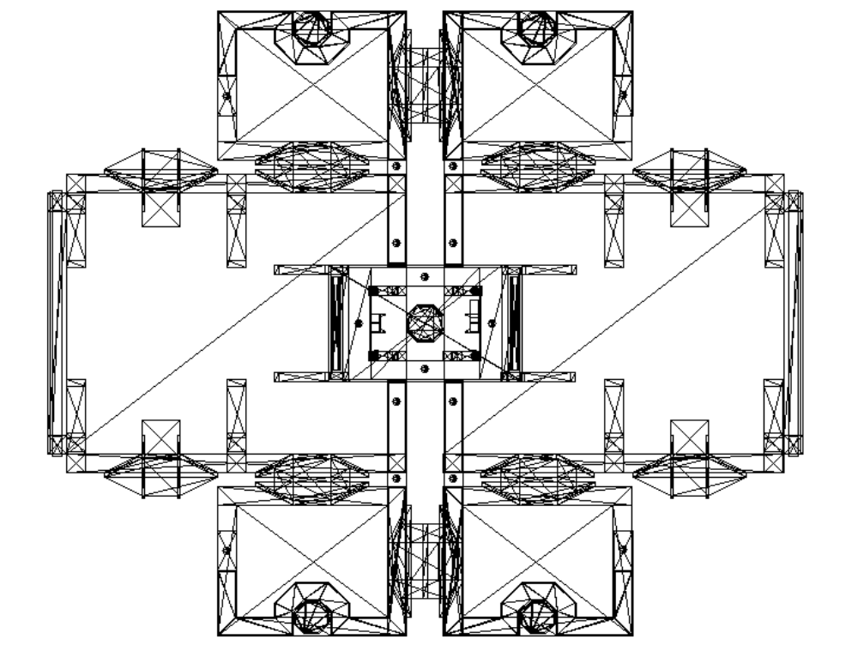
1
SHUTTLE
2
3
4
5
6
7
SECTOID CRAFT

Legend:
Sectoid.Unarmed
Plasma
Neuraliser
Etherial
Sectopod

Ascidian

Map Level 2

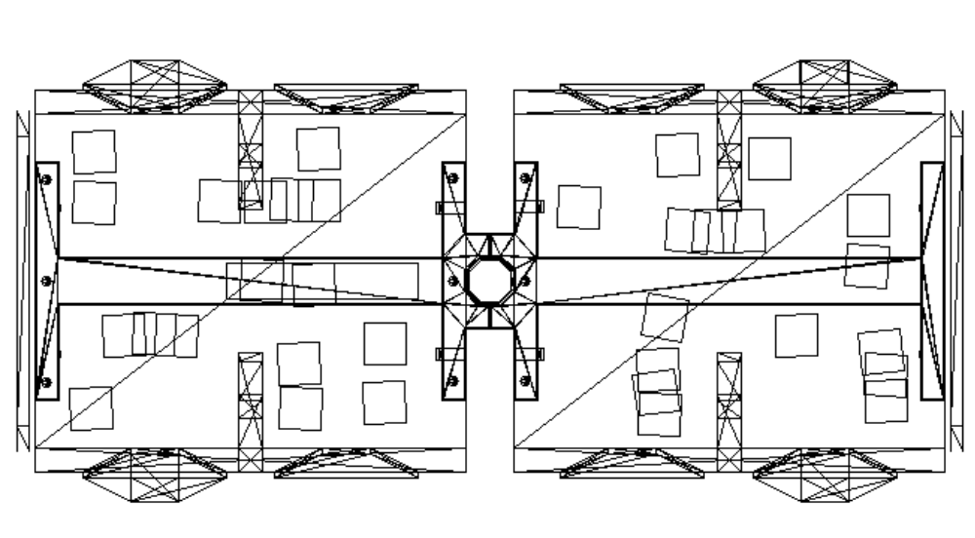
8A
8B
8C
8D
8E
8F
8G
8H
8I

Map Level 3a

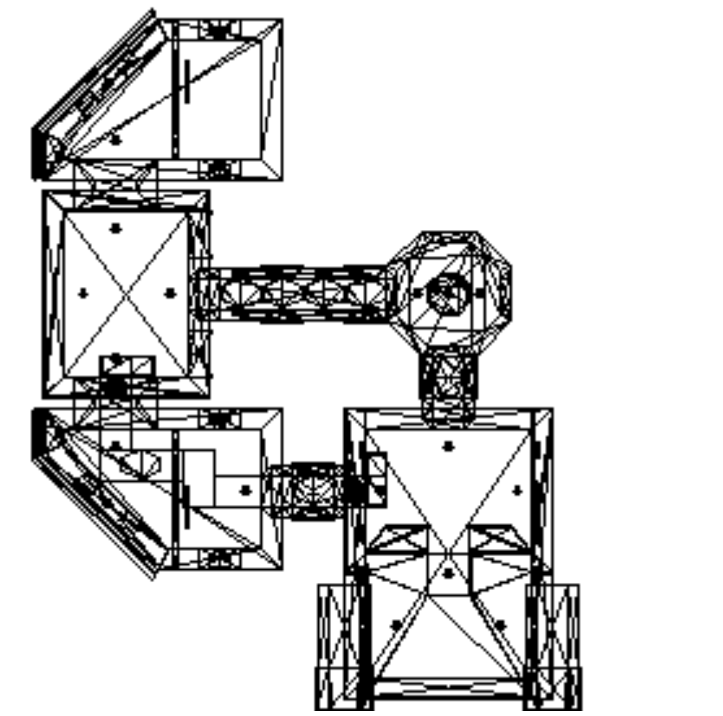

Ducts under rooms 12/13
9
10
11
12
13B
14
15
16
17
18
18A
19
9B
19B
20B
20
21
21B
18B
21C
10B
13

Tube1
Tube2

Map Level 3b
Tube1
Tube2

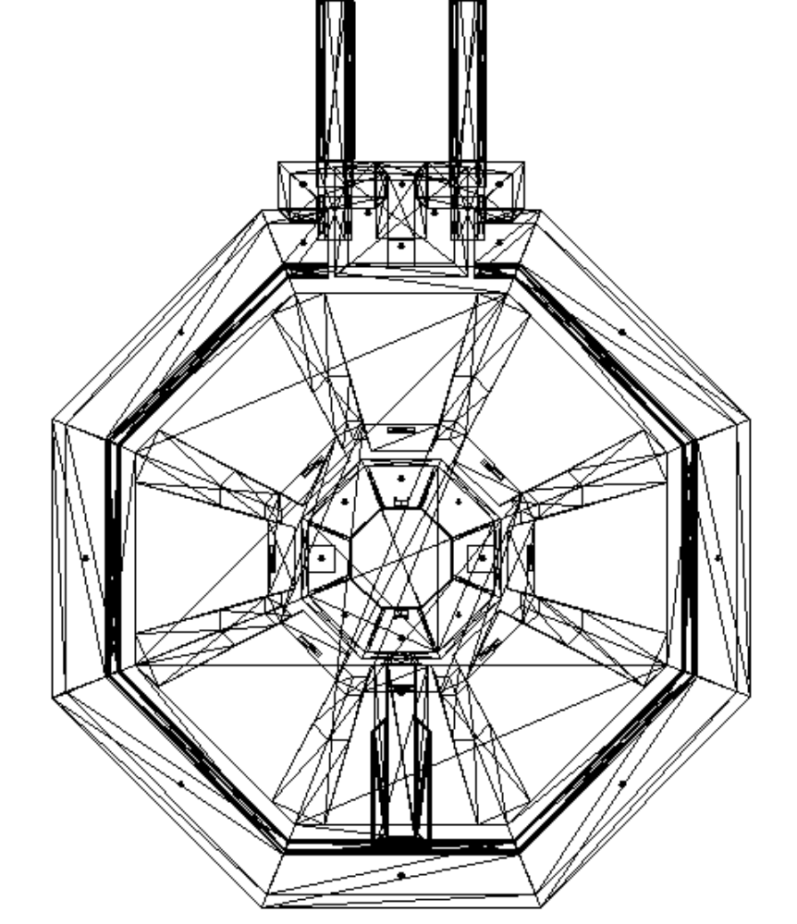
22
23
Below 22
24
24B
24C
25
26
27

Map Level 4

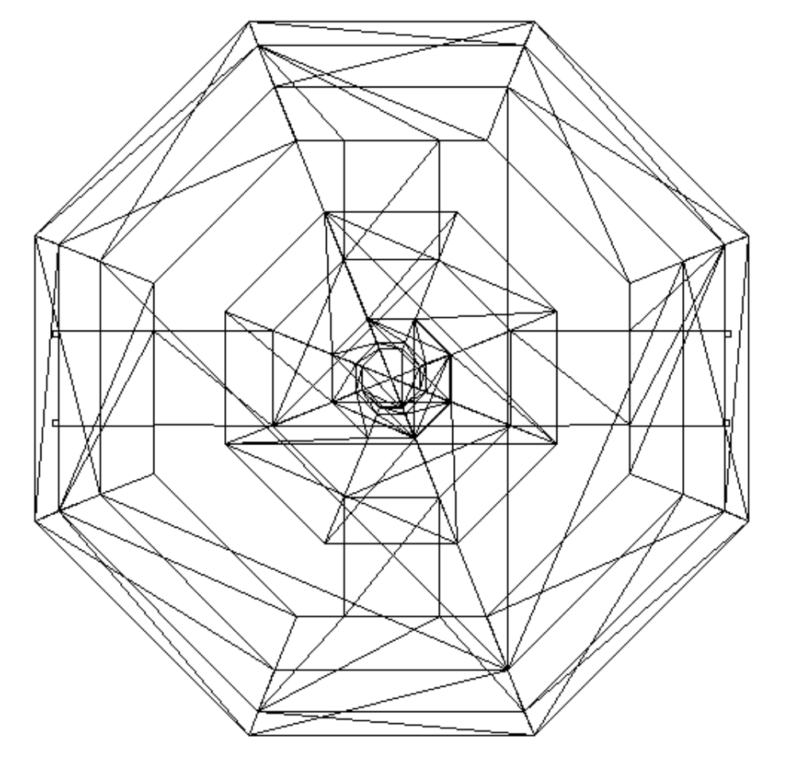
28

Intro to Level

TBD

What has gone before

In an earlier mission the squad contracted a plague virus.

In the previous mission the player was despatched to Tiamet (a jungle world), on the trail of possible samples of this virus to help in creating a vaccine.

The samples were possibly present in the remains of a snakeman transport that had crashed on the surface.

The player undertook a desperate one-man mission via drop pod.
He had to not only find the viral agent, abut evade capture and survive until the Patton could arrive to pick him up.

Now the Patton rejoins the Ascidians for an attack on an atmospheric defence station high above the surface of the Sectoid homeworld ( Sectus)

In order to make the planet below accessible to Ascidian fighter craft the defence grid, that protects the planet below from unwelcome visitors, needs to be taken out.

The humans aboard the Patton, with their psionic resistance, are the ideal vehicle for this.

Using captured codes and CGI the Patton ‘fakes’ reports that the Shuttle has been captured and is ferrying prisoners to the station.

The squad will have only a very short time before this deception is discovered.

Once aboard the station, the Squad has several tasks to complete:

- It has to continually destroy any security ‘cameras’ along its route, this ensures minimal hassle from defenders.
- The squad must also disable:
- Communications: to prevent the station calling for fighter reinforcements.
- Sensors: this should ensure that the attacking Ascidian fleet isn’t seen until its too late.
- Weapons control: to make it easier for the Ascidian attackers.
- Internal station security: this will make it possible to get out again without alerting security from other wings of the station.
- The squad must also place a transceiver near the site of the main power generator so it can be targeted. Once started, the chain reaction should take out the entire structure after a predetermined time to allow the squad to get back to the shuttle. This predetermined time will be continually reset as the player moves back across the map so that no matter what he does, it feels as though he is racing against the clock.

Although not a major part of the mission, the Patton will radio observations to the squad, observations that imply that the Ascidians have possibly been hiding something.

As with the Elerium mine, the mission needs to be synchronised with attacks from the Ascidians so a tight timetable is required. Certain areas of the map will be hit before others, it is essential not to be in those areas.

Lower priority
An Ascidian ‘prisoner’ will be found in one of the harder to reach areas.
If rescued, he will tag along with the rest of the squad (as for the transport ship), and possibly even escape with them at the end.

He will be very grateful for his rescue. The longer he survives, the more ‘details’ about the Ascidians he will give away’

Player Mission briefing:

Given by the Captain

“To-date we’ve been lucky, but now we are approaching the Sectoids home planet, Sectus, and its certain things will get a lot rougher from here on in.

The Ascidians, bolstered no doubt by our activities, are feeling confident, and are planning an attack on Sectus itself.

It is probably a relief to know that we will not be taking part directly in this attack, instead the Ascidians want our help in taking out this orbital installation.

The base is an atmospheric defence station, which co-ordinates a high altitude defence grid, destroying it should make Sectus accessible to Ascidian fighter craft.

The squad will board using the Patton’s shuttle.

To avoid becoming a target we have used captured codes to fake a report that the shuttle has been captured.

These codes were taken from a small Sectoid scout craft that was destroyed earlier today.
We have also programmed the onboard computers to generate a CGI Sectoid and we are confident that this subterfuge will gain us access to the landing bay..

You may have only a very short time before this deception is discovered, you can help prevent discovery by destroying any security sensors you come across.

Once aboard the station, the Squad has several tasks to complete:

You must disable the communication wing to prevent the station calling for fighter reinforcements.

You must disable the stations sensor array to ensure that the attacking Ascidian fleet isn’t seen until its too late.

You must disable the Stations external weapon systems to make it easier for the Ascidian attackers.

And in order to be able to get out again you will need to disable internal station security.

Finally you must place a transceiver here, near the site of the main power generator, so the Ascidians can target it.

Once started, the chain reaction should take out the entire structure.

Once the attacks start, these areas will be targeted. To avoid injury it is essential you are not in those areas when the attack is underway.”

# These areas will be marked on the map, and should be shown on the mission briefing.
The first area will be one which the player can only get to if they act quickly.
The second area will be the area around the shield generator (which will eventually blow up)
The third area will be the ‘cargo area’ and the opposite hanger bay.

Structure of level

Overview

A story (plot)
Aid the Ascidian assault on the Sectoid ‘homeworld’

B story (subplot)
Realisation that the Ascidians are hiding ‘something’

Game Aim
Take out security cams
Disable long range scanners, shields and defences.

Game function
Time limits, variable difficulty depending on actions and very tough opponents

Number of troopers
I consider this to be 3 man squad mission.
This will then allow the player to ‘pick-up’ the Ascidian, later in the mission. (Although due to current difficulties this is currently not seen as essential to the mission structure)

Taking out surveillance cameras
A large number of rooms will have surveillance ‘cameras’.
- These should be relatively simple constructs that can be shot at.
- They should have some distinctive feature, (possibly a glowing green LED like light)
- They should explode in the same way as the Ascidian power boxes on the Ascidian Asteroid Space station, leaving a brief glowing and shorting legacy behind.
- They should all be linked to the spawning of specific encounters.
Ie. A fair number of spawnings will be conditional on a camera still existing.
- These conditions will not be marked on the map as it would get very messy, but are described in the room by room breakdown.
- NB. It would be probably be easier if the program could keep track of these as a ‘group’ so that (for example) spawning could be started by a trigger if ‘any’ ‘camera’ of group 2 was still in existence.
- For the purposes of this doc I have broken them down into several groupings each containing one or more camera.
- To be honest whatever is easiest to do to get the same or similar effect would suffice, so if the above is too tricky, suggest an alternative.

Level creatures
- Sectoids (all types… but no high mentat this time)
- Drone Sectoid textures should be the silver suit versions #

#The suit isn’t necessary a ‘silver’ suit, as most people seem to think the idea of a silver suit is a bit naff.
Rather it is the suit that represents virtual immunity to plasma fire…but I’ll continue calling it a ‘silver suit’ for convenience.

- Sectopods

- Etherials Need the following variations.
- Unarmed (more prone to use Psychic attack than the others
- Armed with ranged weapons (powerful)
- Ideally there should be several variation in skins - for decoration only - with different coloured cloaks and patterns. (This is low priority, but will improve the look enormously)
Etherial Attacks
TBD

Rescued Prisoner
In ‘Room 21C’ the player will find an Ascidian. This Ascidian will ‘join’ the squad in the same way as is planned for the ‘transport ship’ level (still to be specced)
The payoff for the player will be:
- Extra manpower in fending off the enemy.
- Verbal clues and discussions that will happen at various places/times.
- The longer the player keeps the Ascidian alive the more information he will get.
- The player will also get a different debriefing if successful and he manages to get the Ascidian out alive. (This should not be easy…the Ascidian should throw himself into battle with gusto, and consequently run the risk of dying.)
- Ascidians should not obey all the orders given to them by the player.

Ascidian Verbal communications. (To be finished)
(Initial thoughts are that Ascidians should talk almost monochromatically, and with a noticeably different syntax that makes them a little difficult to understand…their statements should be short, and in a whispered croak - possibly slightly feminine
The ‘grammatical ‘switch’ should be possible in other languages…but if not translate the straightforward meaning)

NB. There will be additional dialogue for other levels with Ascidians. I am also aware that the actual categories of trooper response may be a little different to what is listed below.
Change the responses below, where necessary, to fit in with the existing structure. Just keep to the basic meaning and intent.
NB A vast majority of this is non level specific, but hasn’t been specified anywhere to my knowledge. It is needed to allow any Ascidian to interact at the most basic level.

General (Comparable to trooper speech)
NB. All the following apply to ‘Friendly’ Ascidians.
TBD
- Affirmative (general affirmative commands)
“As you wish”
“Agreed”
“Obeyed”
“Command you, I obey “
(Use one at random)

- Negative (general negative commands)
“Rejected”
“Non agreement”
“I Disobey”
“No obey”
(Use one at random)

- Attacking enemy
“Die all hell spawn of Ancestors”
“Eliminate all dark progeny”
“Die swiftly”
“With pain die screaming”
(Use one at random)

- Retreating
(Ascidans should not back away from a fight, unless fear is invoked by psionics)
- High pitched squeal (a little ‘pig’ like)
- Ascidian ‘warble’ (short language phrase..shrieked) ver 1
- Ascidian ‘warble’ (short language phrase..shrieked) ver 2
(Use one at random)

- Alien contact
General
Single Contact
“Ocular contact”
“I have vision”
Multiple Contacts
“They are here”
“They come”
(Use one at random)

Then, if possible, if specific alien types seen. (take the highest rank if more than one):

Alien type | Phrase(s)
Drone | Minions
Commander | A Controller of minions
Mentat | A Mind whisperer
High Mentat | Mind Scourge
Hive mind* | The Spawn mind
Snakemen | Servants
Etherials | Dark servants
Housekeeper | Dwellers in the dark
Chrysalids | Abominations
Modified Ascidians (Both types) | Children of darkness
Tunneler | Eater of mountains
Other | I know not what
Ascidians (including the spy) | Friends
*(probably will not be used…but its here for completeness, and just in case!)

- Under fire
“Injury I risk”

- Out of ammo
(This shouldn’t happen)
“Unarmed am I”

- Death
- Death ‘gurgle’ (like blood in throat as the body collapses)
- High pitched scream cut short (for gib)
- A scream, eg, Aye - eeeeee

- Taking Damage
“Wounds I gather”

- Taking Damage (friendly fire)
NB. If more than, say, 4 shots hit the Ascidian, then he should convert to ‘hostile’ (exact number to be determined by playtesting)
“Desist from reckless aggression”

- On being given a waypoint instruction
“I go where you command”

- Approaching Waypoint
“Approach I lurk co-ordinates”

- Waypoint Reached
“I lurk where requested”

- Request aid
“Assistance is requested”

- Heavy hit
Aarrggggh - (almost a husky squeal)

- Light hit/environment hurt effect
A pig like grunt/squeal

General (as spoken by unfriendly Ascidians, while they are attacking)
NB. All normal responses to commands, and general speech should not take place.
TBD

- Converting to hostile
“Hierarchy correct, trust not humans”

- Ascidian attacking trooper
“Die source of ancestral woe”
or any of the attacking enemy phrases

Possibly level specific (phrases will be reused where possible on other levels)

- On being given an order to:
- hold fire
“Tolerate I no restraint against mine enemy”
(he will effectively refuse the order)

- Guard
“None shall pass”
(he will obey the order…this will then be the only way the player can stop the Ascidian from firing at will)

- fire at will
“Live I to destroy mine enemy”
(he should default to this at the slightest provocation)

- fire on my target
“Aid is given”
(he obeys the command)

- follow me
“Lead on ally”
(he obeys the command)

- On being given any other order (such as inventory)
(general negative message)

Level specific

- On being rescued.
“Not Sectoid you. Human you. I grateful.”

- On making it into the tube train
“Ah vision! There is more than rescue at hand”

- On getting into room 28
“This construction destroyed must be. Ancestral home from the spawn of two worlds must be freed”

- On getting into ‘room 8’
“You fight well. Humans unlike image. Fight accompanied by honour. Leaders wrong. Why?”

- On getting into ‘room 1’
“Surprised … As creatures you shine in the darkness…Histories wrong. Tell you fact … Trust not the words of the Hierarchy.”

- On getting into room 11/15/18 (overlooking the battle)
“Mine people, proud I of warriors. But ashamed those that decisions make. Deserve better allies you.”

- On being mortally wounded (if time…obviously if gibbed no chance!)
“Trust my people not, harm they wish, scared are they…Urghhh”

Set piece Dramatics
It would be very very nice to have the battle seen going on outside the station through the various windows.

This could be carried out as two levels of complexity.

- Very low poly models (put in as creatures attacking and destroying them selves in the skyzone.) This would then allow them to fire and be destroyed/respawned etc. It would look spectacular, and could be reused on other levels.

- The same, but carefully scripted to zoom about the superstructure and fly close to the station so the player would get a ‘star wars’ like look of the Ascidian an Sectoid craft strafing the station. Again they could be relatively low poly. But this time there would be a limited number of set manoeuvres which would be triggered by being in the right place.
E.G standing by the window in ‘Room 18’ could trigger a sectoid craft, pursued by an Ascidian spaceship to come banking round the superstructure, in and out of the pods, and vanish around the corner.
These ‘sequences’ would be easy to keyframe if the program permitted. I would be happy to set them up if the scripting could be pointed out to me.
Only a few of these would need to be made, but they would carry a high wow factor. (each would only be triggerable once from the same trigger, but note that the same sequence could be triggered several times from different viewpoints, and none would be any the wiser.)
This is relatively low priority.

Time limits
The Squad will be working to specific time tables.
- Time to start of Ascidian attack: 1 minute after the Sensors are taken off-line.
(Shown as text and a counter on the screen.)
After this time there should be random screen shakes and sound FX indicating the station is under attack.

- Time to Ascidians hitting 'rooms 10/9B/9': Should occur 30 seconds after the transmitter is placed in the 'correct place' (Room 28).
Not shown…(Unknown to Player)

- Time to Ascidians Hitting the Main reactor (10 minutes after the transponder is set).
(Shown as text and a counter on the screen.)

*These times could be used as a difficulty setting for the level.

Patton Messages
In general the Patton should maintain radio silence for this mission, but it should interrupt with messages at appropriate times, these times will either confirm that the layer is doing the right thing, or berate them for not doing it right.

Setting the transponder for the Ascidians (in the correct place)
“Transponder signal received. Now get the hell out of there”

Setting (or trying to set) the transponder in the wrong place.
“Transponder position non optimal, please reposition.”

Five minutes to Ascidian attack on main reactor
“Five minutes to Ascidian attack on main reactor”

Three minutes to Ascidian attack on main reactor
“Three minutes to attack”

One minute to Ascidian attack on main reactor.
“You have one minute”

20 seconds before attack
“Twenty seconds to main reactor strike”

5 seconds
“She's going to blow …get out of there”

Getting into a tube train, or setting the transponder, without closing down all the consoles.
“Patton here, our sensors indicate that the installation is still on line. You should have closed down all the station consoles by now. If the attack goes ahead they’ll be massive casualties”

Data Downloads

General
Data downloads are possible on this level if the player takes a data download unit.
This is ‘bonus information only’. And is not part of the main mission.

Data download units will be used in this way to:
- Add extra text to the mission debriefing (for storytelling purposes or clues for following maps)
- Speed up current research.
- Provide advance research capability to shorten, or eliminate, future research projects.

For this particular mission
In this particular mission the following text should be appended to the ‘successful’ mission debriefing.

“The data download you brought back has furnished some interesting information.

Firstly, it has confirmed something that our scientists had begun to suspect.
Sectus is far more densely populated than it should be.

According to our allies, the planet was taken only a few decades ago. Sectoid records, from the download, confirm that this isn’t the case.

Although the download contains little direct data, some of the astrophysical records seems to go back several centuries.
It would seem that the Sectoids have been here far longer than we were led to believe and that the Ascidians are not telling us everything.

Secondly, intelligence recovered from the data downloads has given us some clues to Sectoid strategy.

It seems that Etherials are used to keep Ascidians away from important sites.
There are also indications that Sectopods and housekeepers are used to patrol out of the way installations.”

It should also fast track any research in Sectoid weaponry currently underway so that it is automatically ready for the next mission. If this is the case, also add the following to the debriefing.

“The data download you obtained during the mission has also allowed us to speed up research, allowing some projects to be completed well ahead of schedule.

Well done.”

These bonus data downloads will be used on many levels, but unpredictably.

Transponder

This is a small device which alerts the Ascidians to the power core. It should be Ascidian, but relatively simple (and low poly). It should also animate slightly once positioned.
Suggest possibly a small pyramid, whose top half folds open to reveal something inside. (something simple…a spinning or pulsing cylinder)

Recommended Crew members

None

Level B2 Walk through:
NB Rooms are not strictly in numerical order, they are in the order they are likely to be met in the mission.

Act 1
Room 1 Setup (Hanger bay A)
- (Intro)
This is a possibility suggested by Nick Thompson. It is not high priority, but is placed here as an indication of what could be done relatively easily to set the scene on every mission.
- The level should start with a fly through of the outside geometry.
- The ‘landing audio’ starts playing during this ‘fly-by’.
- This camera is then ‘swapped’ to the trooper view just before the shuttle in the landing bay is actually seen.
- The rest of the ‘landing audio’ is played.
- The whole of this time the squad is immobile, they can only start moving when the restraints open (in the same way as for the breaching pod).
- Dialogue:
Patton(01):
“You are now approaching the atmospheric defence station, activating Sectoid code and transmissions” …static…
this is followed by several seconds of Sectoid radio speech, and Sectoid countdown to landing (say 6 seconds) the ‘cut’, from free camera to trooper1 view, should probably take place about 2 seconds into the Sectoid speech.

The squad thus starts out in the belly of the Patton shuttle.

- The landing bay is empty apart from the shuttle.

- The shuttle needs to be finalised, it is used in many missions and we need:
- To revisit the shuttle, the current model is prone to polydrop-out
- To change the size slightly (approx. 20% increase at my estimate.)
- To get the definitive texture sorted and drawn from Greg’s version in the cut scenes.
- To get an inside area for it completed which can be positioned elsewhere using a warp zone (It then isn’t totally dependant on fitting the external geometry). This inside area should fit the Patton style and have similarities to the breaching pod. (ie should have restraints in a similar manner and use similar textures).
- A ‘go’ button needs to be added to the inside of the shuttle for the player to punch at the completion of the level (a similar one needs retrofitting to any level with the breaching pod).
- The Shuttle should be positioned so that it minimises views of the internal area and keeps the poly count down.

- ‘Camera sensors’
There should be three ‘camera’ sensors mounted in the bay.(all group 1)
- The first should be near the lift to the control room.
- The second should be near the main exterior door, looking into the hanger.
- The third should be high on the inner wall looking out into the hanger and space.
NB These sensors should never give environmental analysis results.
- The cargo lifts to Map level 2 are disabled.
They should give an audio downbeat tone if an attempt is made to summon them.

- The access lift to the control room is similarly disabled.

- If after sixty seconds all group 1 cameras are not disabled, three Sectoids with the most powerful weapons that exist so far, should be spawned in the control room (room 7) and they should make their way out onto the balcony in room 1. (Either side, 2 on one side, and 1 on the other would be ideal.
NB these are in addition to the Sectoids placed on the map.

- The death of one of these should trigger the Two of the Sectoids just behind the door in ‘Room2’ (It doesn’t matter which)

- The death of another should trigger the Sectoid just behind the door in ‘room 6’. (Again it doesn’t matter which)

- When the Sectoids in ‘room 2’ activate they should also activate the 2 sectoids just behind the door in ‘room 7’.
NB. This should be conditional on there not being too many Sectoids already active, say 3 or less active)

- When the Sectoids in ‘room 6’ activate they should also activate the Sectoids just behind the door in ‘room 7’.
NB. This should be conditional on there not being too many Sectoids already active, say 3 or less active)

Room 2
- Two Sectoids, providing they haven’t been activated earlier. They should respond as you enter their LOS.

- Getting onto the gantry and arriving at the arch between ‘room 2’ and ‘room 1’ (with a view through ‘room 1’ to the door to ‘room 7’). Should trigger the door to room 7 (only once). This should have the effect of activating the remaining Sectoids in room 7 by LOS (The three by the console overlooking the other hanger bay should be exempt from this until the player actually enters ‘room 7’)
- There should be a distinctive energy sound (crackling like a bonfire?) associated with each of the energy tubes in rooms 2/3/5/6

Room 3 |
Room 4 | (Nb Rooms 3/4/5 are not accessible on the way up)
Room 5 |

Room 6
- Single Sectoid, providing it hasn’t been activated earlier.
- Getting onto the gantry and arriving at the arch between ‘room 6’ and ‘room 1’ (with a view through ‘room 1’ to the door to ‘room 7’). Should trigger the door to room 7 (only once). This should have the effect of activating the remaining Sectoids in room 7 by LOS (Again the three by the console overlooking the other hanger bay should be exempt from this until the player actually enters ‘room 7’)

Room 7 (Hanger bay Controls)
- There are a lot of Sectoids stationed in this room, they should mainly however have already been activated, in waves, before the player gets this far. (The route to here is largely single file, and the various Sectoids should have been despatched before the player can make it this far.)
There should therefore only be 3 left by the time he arrives here.
One unarmed, one with a ranged weapon and one with a neuraliser.
These Sectoids should be positioned so that they can be activated by LOS only after the player enters the room.

- There are two lifts down to the hanger bays.
- The first goes down into ‘room 1’. Initially this didn’t work from ‘room 1’. This lift should be useable from this room, and should work normally from now on so the player can descend to ‘room 1’ and return to ‘room 7’ without problems.
- The second, which descends to ‘room 4’ should be still disabled.
Trying to use it should elicit the usual ‘dropping’ Sectoid negative ‘tone’.
(The lift will be activated later and will work fine from then on)

- The lift up in the centre of the room needs to be ‘hinted at more. It needs a lift button and symbol associated with it.

- All lifts need to be 'triggerable' by a key-press, and not by timing or proximity.

- Polycount has suggested that the windows into his room will not be able to look out into the hanger bays.
Some of this problem might be due to the fact that the map is not yet zoned, and it may prove ok to have the windows one way.
However, if the windows can't look out into the hanger bay, then these surfaces need to be covered with station schematics.

- Even if the above proves possible Station schematics still should be visible in this room, preferably as floating holographic displays.

- ‘Camera sensors’
There should be two ‘camera’ sensors mounted in this room. (Group 2)
- They should be in diagonally opposite corners of the room so they can ‘cover’ the entire area.

- If the lift is called, and one or more of the group 2 cameras are still in existence then the lift should contain 2 Sectoids.(spawned specifically) Otherwise it should be empty.

- The room should have a sort of rythmic pulsing sound associated with it. Whatever sound is chosen it should only be used in areas where large numbers of consoles are. (ie: rooms 7/11/15/18/21)

Room 8/B/C/D/E/F/G/H/I) (NB these rooms are not accessible on the way up)

Room 9 (lift to Map Level 3a) Plotpoint 1
- The door to 'room 13' is 'unlocked'

- The door to 19B should be locked. (It should be openable from room 19B, and will then operate normally).

- The door to 21B should also be locked. (It also should be openable from room 21B, and will then operate normally).

- Area should be made more dramatic.

- ‘Camera sensors’
There should be four ‘camera’ sensors mounted in this room. (Group 3)
- They should be one covering each exit off the central core, and positioned on the ceiling.
- Room 9 will have the lift made impassable when the Ascidian hit 'rooms 10/9B/9' (see Time limits at start of this section).

- When the Ascidians ‘hit this area’ There should be debris fall from the roof, and any creatures/troopers inside should take severe damage. The lift should be damaged, and there should be debris (struts or pipes fall down inside and wedge there) showing clearly that it is inoperable.

- The area should be left looking damaged with things hanging down and panels fallen from the wall, areas behind sparking.

Room 9B
- The door at the end to 'room 10' should be locked. (It should be openable from room 10, and will then operate normally.)

- When the Ascidians ‘hit this area’ There should be debris fall from the roof, any creatures/troopers inside should take severe damage. The corridor should end up blocked off by the fallen debris.

Act 2
Room 13
- The lighting should be looked at a little, and some larger support struts added to the outer wall.

- The lift's position needs to be made clearer. To do this I suggest it needs to have support rails/struts added, and the lighting used to make it stand out more. It also needs to be altered so it has to be activated by a key-press.

- The door to 'Room 12' should be unlocked.

- The door to 21B should be locked. (It should be openable from room 21B, and will then operate normally).

- The door to the vents,'13B', should be locked.

Room 14 (Top bit near the tube connectors)
- Better motivated lighting.

- Alter the glass textures to be 'clearer'.

- Add glowing view screens with Station Schematics (in particular showing the 'tube' network)

- Add two Sectoids armed with ranged weapons (use the most powerful available)

- Add tube train 'switches' to call the trains. These should have a texture associated with 'deactivation'. This texture should match the switches that activate them in 'room 21'.

- ‘Camera sensors’
There should be two ‘camera’ sensors mounted in this room. (Both Group 3)
- One should be positioned overlooking each 'tube arrival point'.

Room 14 (Bottom bit underneath the tube connectors)
- Add pair of consoles, and security screens.

- Ideally add a view port looking out, and up, at the transport tubes.

- Place a Sectoid armed with a neuraliser at each.

General Note about the 'wings' (Rooms 11/12, 15/16, 18, 21)
- Each 'wing should be lit distinctively different, suggestions are placed in the relevant room descriptions, but the important part is that each is different and distinctive.

Room 12 Pinchpoint 1
- This is the 'Communications wing'

- Suggest lighting predominately green.

- The view screen should have a stylised image of the planet, with various orbiting satellites shown, linked by 'lines of communication'.

- There should be no less than three switches. Each of which should toggle between an 'on' and 'off' state, with appropriate textures. Each switch should also toggle off one or more lines of communication to the other satellites.

- When all switches have been turned off all lines of communication to the station should look severed on the display. (This could be carried out using appropriately textured movers that 'flip' out of the way.

- ‘Camera sensors’
There should be single ‘camera’ sensor mounted in this room. (Group 3).(Place over the door 'room 10')

- A single Sectoid should be present in this room.

- One of the consoles should be distinctive, and use a texture which we will use always for data download panels. If the player has brought a data download unit he will gain extra information here. (This should be retrofitted to areas in previous maps (notably mission 1) where data downloads are required to be carried out.

Room 11
- ‘Camera sensors’
There should be single ‘camera’ sensor mounted in this room. (Group 3) (Place high on the ceiling, overlooking the main screen display.

- The overall colour hue should tie in with 'Room 12'

- There should be a console or two showing an image relevant to the wing. This could be anything, abstract images of data streams, or information being processed, representations of radio dishes/transmitters or incoming image sequences (jumbled).

- Two Sectoids should be present. Both armed only with a neuraliser.

Room 10
- Door to 'Room 15' should be unlocked.

- The vent to the ducts 'Room 13B' should be unlocked.

- Room 10 should be made a lot more 'structural'. I want to see large support struts (this is an outer edge of the station) and the 'boxiness' of the room disguised.

- Add a console or two to the room, A view-screen and a teleport pad. The console should control the teleport pad.
The console should use the teleport active/inactive textures that have already been finished.

- Starting from the moment any trooper enters 'room 9', and ending when the teleport is turned off.
- For each minute any camera in group 3 still exists, a Sectoid should be spawned in 'room 10'. With instructions to follow the following route.
Room 9B, 9, 13, 12, 11. (If at any time any Sectoid get LOS on a trooper they can react as normal)
- Every 1-3 minutes (randomly) the door between 'Room 10' and 'Room 9B' should open for about 30 seconds
This would have the effect of sending a small group of Sectoids around behind the player on a regular basis until either all the cameras are destroyed, or the player gets to 'room 10'.

- When the Ascidians ‘hit this area’ There should be debris fall from the roof, and any creatures/troopers inside should take severe damage. (The roof area should be dark to avoid seeing where it actually came from.

Room 10B
- very small secret room. Contains two alcoves with ‘goodies’ weapons and ammo. (opened from the duct room 13B)
- This door should stay open for only 30 seconds.

Room 13B (Tubes Under rooms 11/12)
- Make the ducts more impressive by adding 'grilled sections' showing other bits of the superstructure.

- add a small 'enlargement' of the ducts containing a Sectoid control panel. This panel should have a switch giving access to a secret room, ‘Room 10B’.

- Ideally, with more time this duct system should be expanded to provide a small 'aside' to the main mission. This is not specced out here. Low priority.

Room 15
This is the 'External Sensor Wing'.
- Suggest lighting predominately blue.

- ‘Camera sensors’
There should be single ‘camera’ sensor mounted in this room. (Group 4).(Place over the door 'room 10')

- A single unarmed Sectoid should be present, who on LOS should run into 'Room16'. This action should also trigger 3 armed Sectoids to run the other way from 'Room 17' (They should be at the far end of the corridor so that it takes them a little time.

- The screens here should show images associated with external sensors, planet views, or Sectoid ships being scanned.

- Sound in this area should include some sort of subliminal ‘ping’ like sound. (whatever the pitch)
This should then work on the subconscious that it is a sensor room (the old sonar ‘submarine effect)

Room 16
- The view screen should have a stylised image of the station, with small 'targets' moving around. There should also be two Concentric rings surrounding the Station in a contrasting colour (The sensor ranges)(again done with animated mover overlays).

- There should be two switches. Each of which should toggle between an 'on' and 'off' state, with appropriate textures. Each switch should also toggle off one of the Concentric 'range' circles showing that the sensors have been shut down. This action should also show the input data being shut off by adjacent screens changing from a busy data display to one showing no input.

- When all switches have been turned off all lines of communication to the station should look severed on the display. (This could be carried out using appropriately textured movers that 'flip' out of the way.

- ‘Camera sensors’
There should be single ‘camera’ sensor mounted in this room. (Group 4) (Place high on the ceiling, overlooking the main screen display.

Room 17 (TBF - To be finished)
New Room
- Corridor, should contain the 3 Sectoids triggered in 'room 15'
- No security camera.

Room 18 Midpoint - TBF
This is the 'Main Weapons Wing'
New room
- Suggest lighting predominately red

- ‘Camera sensors’
There should be a couple of ‘camera’ sensors mounted in this room. (Group 4). Position dependent on final layout.

- Three Sectoids should be present. One of which should be operating the consoles, and another should (if possible) be seated at one of the external weapon mounts.

- The screens here should show images associated with the external sensors (same as in that wing) and images analysing the threat values of various Ascidian craft. (The Patton should also be present on one of the displays.
- There should also be a display showing the station and all the gun ports marked with glowing symbols.
- There should be a large number of switches arranged in a linear array. These switches should have two textures linked to 'gun online' and 'gun off-line'.
- Each switch should turn off one or more of the guns shown on the station schematic. The weapons are not considered off-line until all have been deactivated.
(again this should be shown by some sort of overlay)

Room 18A/B - TBF
- These are two of the accessible 'external weapon pods.
- They should look mean and high tech. The pods readouts should shut down when they are taken off-line. Each should ideally have a Sectoid seated within, but this may prove difficult, and is of lower priority.

Room 19 - TBF
New room
Access to hub (room 9).

Room 19B - TBF
New room
Unfinished service area, main function to provide 2 way access to and from map level 2.

Room 20 - TBF
New room
Corridor, main function access from 'room 20' to 'room 9'.

Room 20B Pinchpoint 2 - TBF
New room
Corridor, main function access from 'room 18' to 'room 21'.

Room 21 - TBF
This is the 'Internal security Wing'.
New room
- Suggest lighting predominately dark, with orange low radius lighting.

- ‘Camera sensors’
There should be a couple of ‘camera’ sensors mounted in this room. (Group 4). Position dependent on final layout.

- Three Sectoids should be present. One of which should be operating the consoles, and another should (if possible) be seated at one of the external weapon mounts.

- The screens here should show images associated with the stations internal security. These images should be station schematics, in particular maps from this pod, showing some of the rooms as 'alerted', and positions where the cameras were found flashing.

- There should be a single switch to take the displays off-line, this should be inside a sliding door panel which should be made reasonably/ but not overly obvious.
This switch controls the whole security network, if it is turned off then the player should no longer be hampered by any 'extra security Sectoids'. (ie all group cameras are now considered destroyed)
If it is missed then this problem will continue.

- There should also be display showing the 'tube connections' for the station, associated with a switch that matches the 'deactivated' switches for the tube trains off 'room 14'.
This will toggle the activation state of those switches. (Ie. If activated here the switches will work, if deactivated here those switches will not work)

- There needs to be a small ‘cell’ off this containing an Ascidian.(room 21C)

Room 21B - TBF
- Once this room is entered, if there are any 'group 4' cameras still in existence, the teleport in room 10 should start up again, and remain so until the hidden switch in room 21 is turned off.

- There should be a limit of 4 Sectoids from this transporter at any one time.

- Once created they should follow a route that takes them randomly across the level (or a route that doubles back on itself several times so that it will appear random to the onlooker). This should ensure that the player will not know where they are on his return to his pod.

Room 21C
- A door switch should unlock the cell.

- There should be an Ascidian peacemaker in the security room that he should first go to and pick up.

- The Ascidian should then ‘attach’ himself to the squad. (See rescued prisoner in the earlier part of this section).

Room 14 (Tubes)
- If the switches work then they will activate the tube trains.
- Tube 1 will contain a single Sectoid. Plus 2 Sectoids if any group 4 camera is still working.(All armed with heavy ranged weapons)
- Tube 2 will contain 2 Sectoids.(Both armed with a neuraliser).
- Once a trooper, or player boards a tube train, the other will automatically be triggered.
- Any tube train will automatically return after 1 minute.

Room 22 Plot point2
- This should have displays added similar to 'room 14'.
- The lift down should have railings, or struts addeded to reinforce its function. It should also be re-textured, and better lit, and have its activation triggered by a keypress.

Act 3
Room 23
- Single Sectoid
- Ideally make area more detailed, add a few structural struts and cutaways.

Room 24
Room 24B
Room 24C
- Two Sectopods patrolling in opposite directions, triggered by player entering 'room 23' (perhaps make them the same group as the Sectoid at the base of the lift)

- Area needs to be checked for texture problems and rendering speeed.

- The pipes do not work and need to be removed, or made to work much better.

Ancillary/secondary section (aside) - low priority
- The wall area near to 24C could lead to another viewing chamber, stuffed with supplies.

- It could also lead to a second tube network linking another pod, and even a little extra geometry leading to a view that looks over towards the pod and landing bay where the player started.

- This is low priority, but it should be strongly considered if time permits as it would lead to a good vantage point that gives a true sense of scale. These sorts of view are common in Unreal, but rare in Alliance, and we need to do them occasionally.

Room 25
- No change - but -
- If the ancillary stuff is added (see below) then there should be a force-field over the entrance, which is deactivated by a key card. The keycard will be found in the ancillary section (TBD)

Room 26
- One Sectoid either side of the door, another around the back.

- The lifts down, need to be made more obvious, and activated by keypress. (Otherwise it will get annoying with troopers falling down and having to be rescued by jumping into them).

- The area needs to have more animated consoles and view screens.

Room 27
(Oops mistake.. not really part of the map.)

Room 28
- The room should have consoles added.

- It should also have at least one gigantic view-screen on which data, and various readouts are shown.

- There should be at least one lift, or ramp connecting the ‘well’ with the gantry, otherwise troopers who fall down won’t be able to get out.

- There should be 3 Sectoids in this section all armed with ranged weapons.

- Shooting at the exposed core, should not destroy it, but it should react by sending out a large ‘pulse’. This could be represented by a large explosion. Any creature close to the explosion should of course take damage.

- The transponder should be placed in this room as close to the ‘core’ as possible.(The ideal placing should be shown in the HUD as an environmental box message.)

- Placing the transponder should automatically start the countdown and generate the Patton message (even if the ‘wings’ haven’t been closed down).

- If all the ‘wings’ haven’t been closed down a second message from the Patton should be generated (see Patton messages) warning the player that he still has unfinished business to complete.

- It should be possible to go back and ‘remedy’ this situation.

- If the player manages to close down all the wings before the countdown is complete he will have the remaining time to get back to the shuttle.

- Without the ‘wings’ taken off-line the Ascidians will be unable to complete their attack.

- (If the player hangs around long enough to see the area get taken out by the Ascidians it should be ‘game over’). If he leaves a trooper there, the trooper should simply die, and his screen go to static.

- This area should have a very distinctive pulsing sound. The sound should ramp up and down over several seconds. It should imply immense power.

Backtrack Room 28-Room 9

Room 9/19 (On way back) Crisis
- On the way back the lift down from room 9 will not be in working order, the player will therefore have to go out through room 19.

Room 8 (For first time)
- There should be a trigger at the point the troopers descend into this room.

- The point where the troopers descend into this room should be arranged with crates to be a defensive position. (The player, if he recognises this, will be better of waiting here for the Sectoids to come to him).

- If the transponder has not been placed, then only the Sectoids marked on the map will be seen. These should all be part of the same ‘group’ so that they will attack the player en, masse.

LIFTS
- The two lifts, at 8B and 8B should be locked in the up position, and should not be usable by the player.

- The two lifts at 8H and 8I should be locked in the down position and should also not be usable by the player until they have been triggered by other events.

- If the transponder has been placed. Then the first trooper to descend into room 8 will trigger the lift at 8H to bring the Etherial on it from ‘Room 4’ up to the cargo bay.

- One minute later the other lift should trigger bringing another two Etherials up into the fray.

- Once these two lifts containing Etherials have been triggered these lifts should be operable by the player.

Rooms 3/4/5 (For first time)
- Placing the transponder should ‘unlock’ the doors between ‘rooms 2/3’, between ‘rooms 6/6’ and all doors and lifts linked to ‘room 4’.

Room 3
- If a trooper goes through the door between ‘Room 3 + 4’ it should ‘unlock’ all the lifts between map level 1 and 2.

- Two Etherials, both armed.

Room 4
- Room 4 should have a Small Sectoid craft in the landing bay. There should also be a couple of patrolling Etherials.

- There should be Etherials placed on the lifts to map level 2. (see map)

Room 5
- If a trooper goes through the door between ‘Room 5 + 4’ it should ‘unlock’ all the lifts between map level 1 and 2.
- Single Etherial unarmed.

Room 1 (On way back) Resolution
- If the player, or any trooper goes through either the door between ‘Rooms 2 +3’, or the door between ‘Rooms 5+6’ it should trigger Sectoids to start teleporting in to the landing bay.

- Ideally a check on how many creatures are still active should be carried out and, providing the number is less than 4, more should teleport in.

CONCLUSION
The level ends when the player gets back into the shuttle and punches the ‘go button’ on the console.

Debriefing

Successful:
Cut scene followed by:
“The atmospheric defence station has been destroyed. Only the inner defence shield now prevents the Ascidians from taking Sectus.
The Ascidians have informed us that the inner shield should fall within the next few days.”

Additional if the ‘prisoner’ was rescued and he got out alive at the end.
“The Ascidian prisoner you rescued has been transferred to the Ascidian flagship.
By all accounts he was impressed by what he saw, and extremely relieved at his release. This action can only help in Ascidian human relations and I wish to congratulate you on this action.”

Then add the ’Normal debriefing text’.

Failure:
Not setting the transponder:
“You failed to set the transponder. Without this device, properly positioned and working, the Ascidian attacks were ineffective at destroying the atmospheric defence station.
With the attack ineffective, Sectoid forces rallied and annihilated the Ascidian fleet. They then turned their attentions to the Patton and the Ascidian homeworld.”

Setting transponder, but not shutting down all the ‘wings’:
“The transponder was successfully placed, unfortunately the stations sensors and systems weren’t fully shut down.
When the Ascidian fleet arrived, the Sectoids were ready for them, and their fleet was annihilated.
The loss of so many ships severely weakened the Ascidian forces, a blow from which they never recovered.”

Dying in combat
“The loss of your combat experience undermined the Patton’s ability to mount strategic strikes against the enemy. Mission after mission failed until….”

(Cut to end of game failure sequence)
END OF MISSION

Level B2 Art requirements
Requirement | Description | Size/Bitdepth |  |  | Priority
General
Texture | Patton shuttle texture:  This needs to be re-done to fit in with the textures assigned by Greg. (The Shuttle will be used elsewhere also) | 256*256 |  |  | 1
3D unreal ‘brush’ /area | Inside of Patton shuttle :  This should only use textures present in the ‘breaching pod’ utx.(and then as few as possible)  This should be completed in unreal rather than max to ensure that it is kept as low poly as possible. It should be reminiscent of the breaching pod. | Size should be comparable to the breaching pod. |  |  | 1
Texture | Completion ‘button’ for inside of shuttle/breaching pod. It should be distinctive, and should have ‘Launch?’ written on it (or something similar)  The ‘activated’ version should have ‘Launching’ or ‘Main engines start’ or something similar in a different colour. | Inactivated: 64*64  Unactivated: 64*64 |  |  | 1
Texture | Render of Atmospheric defense station from distance (showing it entire) | 256*256 (for reduction to 128*128) |  |  | 3
Texture | Closer in view of part of station | 256*256 |  |  | 3
Mesh | For destroyable ‘Camera sensor’ (will be used on other levels) | ~16 polys or less if possible
Texture | For destroyable ‘Camera sensor’ | 128*128 (possibly reduce to 64*64 or include on other texture page
In game mesh | Transponder (Ascidian in design)  This should have an activate animation (used when properly positioned)  It should also have a ‘in use animation’ showing that it is doing something (loopable)  These should be very short and simple. | 30-40 tops
Texture | for transponder (above) (Ascidian) | 128*128
Room 7
Texture | Station schematics | 256*256 (with 3) different textures associated with it) these will then be positioned on different screens in the room)  Suggest:  - Plan view:  - Schematic of hanger bays in close-up  - Side view, possibly only of a single pod |  |  | 1
Room 14
Texture | large station schematic of the ‘tube network’ connecting the various parts of the station. (Shown as a Plan) | 128*128
Texture | For train call switch.  This needs to be three states:  Deactivated  Active  ‘Train coming’ | Each 64*64 (combine on one map if possible)
Room 11/12
Texture | Stylized picture of the planet | 128*128
Texture | 3 or 4 frame animation Maskable texture with sections showing.  Line of communication  Active station icon  Inactive station icon | 64*32 (fitted onto texture below)  Combine these onto one single texture with those below
Texture | Animated communications textures for consoles:  Perhaps showing data streams, or radio dishes  (Some can be used scrolling or with other textures to infer lots of activity) | 128*128  Combined other room 12 textures (above)
Texture | Data download texture:  This should always be used only for data download areas. It should also be retrofitted to other maps (currently mission 1) | Standard Sectoid console size…get from Paul
Room 15/16
Texture | Sensor ring On  Sensor ring off:  (Use the same texture at different scale and rotation for inner and outer rings.) | 128*128 (but including those below as well on the same page)
Texture | Switch textures for Sensor wing:  1 Outer sensor ring.Active  Outer sensor ring inactive  Inner sensor ring active  Inner sensor ring inactive | Each texture should be small (32* 32) and combined onto a single texture page to conserve memory
Textures | ‘Sensor blips’  Masked texture, which has several different types (say 3) of blip in different colour | 3 each of which is 8*8 or 16*16 and combined on the abovce texture map.
Room 18/18A/18B
Texture | Switch texture:  Gun on-line  Gun off line | Both at 64*64 Combine with that two below into a single texture(128*256)
Texture | weapon pod control surface texture:  Active  Inactive | Both at 128*64 Combine with that above and below into a single texture(128*256)
Texture | Target icon displays for overlay onto planet (or on separate screen) | Both at 64*64 Combine with that above into a single texture (128*256)  (If possible combine with other textures as well)
Texture | Various Ascidian craft plan/side/front views (use existing textures if they exist)  These should be used to show ‘Ascidian weak points’ or target points | Two @ 128*128
Texture | Patton texture (same as above use existing texture if available) | 256*128 (Combine with the above into a single 256*256 texture)
Room 21
Textures | Animated Station Schematics:  two frame animation showing Station with all areas flashing: | Two frames 128*128
Texture | Switch for whole security grid: (This should tie in with the graphic above.)  Activated  Inactivated | Symbols should be 64*64: put as many of the following ones as possible on the same texture page.
Texture | Switch to Activate the rail network…needs to tie in to the symbol used in room 14 for deactivated/activated state.  Activated  Inactivated | See above
Texture | Switch to unlock the Ascidian in the cell:  Locked  Unlocked | See above
Room 28
Texture | Readout for power core (should be used in conjunction with existing animated textures to imply that the whole hing is animating.)  The graphic should show a schematic of the core, with various readings indicated. | 128*128
NB. See also Environmental analysis for Level A1 for additional entries (Console, Teleport etc.)

Level B2 Environmental Analysis
Object | Title | Detail |  |  | Range visible
General
All consoles/force fields and displays should have relevant Environmental analysis associated with them. (see missions 1/5/12 for details)
Re-use these existing ones where possible, and add the following ones
Etherial corpse | Bio Analysis | Deceased organic biological entity: Form matches type known as Etherial with a 95% probability. |  |  | 64
Etherial ‘gibbed’ bits | Bio Analysis | Fresh Organic material, copper based haemoglobin. Species unidentifiable. |  |  | 32
Sectopod ‘corpse’ | Environmental Analysis | Cybernetic organism, traces of neural matter: Form matches type known as Sectopod with a 70% probability. |  |  | 64
Sectopod ‘gibbed’ bits | Environmental Analysis | Unidentifiable mechanism: Faint biological traces. |  |  | 32
Data ripper compatible Console (retrofit to previous levels where appropriate | Environmental analysis | Digital data pulses detected: Alien computer interface: probability 95%. Data ripper compatible. |  |  | 128
Room by room
Room 4
Sectoid spaceship | Environmental analysis | High Elerium specific radiation levels: 90% probability spacecraft associated with race known as Sectoid
Room 28
Power core | Use as for mission 1
Transponder placing | Environmental analysis | Optimal position for Transponder placement
Ascidian Transponder attack | Environmental analysis | Ascidian attack co-ordinates….Time remaining XX  (where xx is the time to the attack)
 |  |  |  |  | LOS

